Copyright 2008 Society of Photo-Optical Instrumentation Engineers.
This paper was published in Proceedings of Defense + Security Conference and is made available as an
electronic reprint with permission of SPIE. One print or electronic copy may be made for personal use only.
Systematic or multiple reproduction, distribution to multiple locations via electronic or other means, duplication of any material in this paper for a fee or for commercial purposes, or modification of the content of the paper are prohibited.

Bio-inspiration not bio-imitation

Jim Brander*
Interactive Engineering, Sydney, Australia

Abstract
We can be inspired by biological systems, but that does not mean we should attempt to directly implement the components from which those biological systems are built. Particularly with cognitive systems, the properties of the components are submerged by higher level organization. It may be easier to use a process of reverse engineering of the product of a biological system to understand its operation, than theorizing about its operation or attempting to build up the system from its apparent components. The reverse engineering of a cognitive system to handle a high level task is described, including the extensions required to an already undirected structure. It is shown how construction of operators built on demand at a ground state can be used to make up for the lack of the massively parallel activity of a biological cognitive system.

Keywords: Undirected, active structure, active map, relations on relations, diffuse operator, semantic octopus

INTRODUCTION
The animal kingdom has many dazzling examples of adaptation, birds for example. Humans looked at birds and wished that they too could fly. A bird’s wing beautifully integrates lift and propulsion, using a component that is our watchword for lightweight structures – “as light as a feather”. So, people copied the bird’s flight mechanism and built ornithopters. Without an adequate power to weight ratio and the close coupling of nerve and sinew of a living system, these were bound to fail. If we looked a little further afield, to bats and insects, we would have seen less gainly structures, successfully flying without feathers. At the time we were trying to copy them, we didn’t understand that it was a higher level ability, the ability of the nervous system to drive a wing through a complex motion, that allowed all these biological systems to fly. We separated lift and propulsion, we introduced energy flows beyond the power to weight ratios of living systems, and we built flying machines no bird could match. We also did things no cellular animal can do, like having a revolving shaft for a propeller or turbine (a flagella is close, but not scaleable). Later, we merged lift and propulsion back together, developed a complex wing motion and arrived at a helicopter, a much closer analog of a bird. We walk on our feet, but our cars have wheels. We are right to be inspired, but we also need to keep in mind both the higher level organization, and the limitations that biological cells must work under.
To depart from biological systems for a moment, we can stare at a transistor for as long as we like, but it will help us little in designing a computer. The high level organization is more important than the properties of the low level component. That is not to say we should ignore the properties of the components completely – the ability to manufacture millions or billions of transistors very close together is important, but only when the required organization is understood – the organization is the concept, the component is part of the execution.
When we look at cognitive abilities, the separate-and conquer-approach for lift and propulsion, or the application of brute force instead of subtlety, was never going to work (well, almost never – brute force works for chess, but the rules of chess are long term stable). If we look carefully at neural organization, what do we see? We see neurons moving information into and out of the cognitive core, but they do not appear to have anything useful to tell us, in comparison with using wires for the same purpose. Within the core, we see a very large number of neurons (perhaps a hundred billion), and only neurons. We see individual neurons with many connections (thousands). Each neuron has a direction of operation, and it works, within the core, by activation of its connection to other neurons. Connections can operate by excitation or inhibition.

What should Inspire us?
Which are the things that should inspire us, and which are the things we should ignore as interesting but unnecessary, like a feather? Having everything made out of the same stuff seems useful, as only a single resource needs to be managed. We also have direction and connection, but before we decide these are inspiring, let us look at the other end of the system. If we try to theorize how the highest level of cognitive activity works, it is like chasing shadows (we don’t have sufficiently generalized and dynamic mathematics or a logic broad enough to support the theory, so we end up looking at facets, like the elephant’s trunk mistaken for a snake). We could look at the gross physical structure of the brain, work out what each piece does, the hippocampus say. But it doesn’t feel like there are different pieces required, it feels seamless, and then we find an example where all the specialized structures are destroyed and it still all works in a fashion¹, illustrating why the usual analytic methods of system decomposition would be ineffective for cognitive applications.
Logic is meant to be a simplified description of how we think. Perhaps it can shed some light on those properties that are important. Modus tollens gives us
If A then B
Not B
Then not A
We have neurons with direction at one end, and we have modus tollens at the other. This suggests that directionality is not a necessary property, and we could use components that do not have it (we don’t know how many layers of directed components are needed to build a structure that appears undirected, but we should need fewer undirected components). It goes further. With the same statement,
If A Then B
Not B
A
we can see the statement itself is false (or does not currently exist), which invites us to explore the logical source of the statement. Logic paints a much richer world than we usually allow it – it was implemented crudely in the early days of computing, with a jump in code, and then we decided that what we had implemented was logic. If real neurons can support modus tollens, can support reasoning about reasoning, perhaps we should ask whether it was excessive attention to the components that caused us to throw this obvious property away.
Connection is a little more difficult to discard. Those billions of neuronal connections were built up slowly over time, and have a purpose. But neurons can create new connections, so we have to at least understand how that might happen. Let’s use a machine as a prop – the Jacquard loom. The Jacquard loom takes a program on a paper tape and operates the loom so it produces a pattern (why not use a computer as an analog? – the woven output of the loom is conceptually closer to a neural structure). When a thread breaks, the person attending the loom rushes out and fixes it. It can be any thread, in warp or weft, of any color. There is an implicit connection – the person is attending the loom – and the person can determine by its connection, which thread is to be repaired, but there is no direct connection, in the way there is for the threads in the woven pattern. We will later describe this mechanism as a semantic octopus, using as inspiration the octopus with its eight tentacles – humans have a limit of somewhere between six and eight loose ends. It is an ability to move to a local site of discontinuity – establish local context, grasp the loose ends, knot them together, and move away to await the next discontinuity. So, just as directionality of operation can be overcome by layering, the need for direct connection can be overcome by sufficient layering. As the purpose of operation without direct connection is to establish direct connection, it would seem that direct connection is an essential mass property of a cognitive structure (but unnecessary locally).
We will encounter conceptual problems with neuronal direct connection – problems that can be solved by instantiation, but this doesn’t seem to be a solution available to the biological cognitive system, at least not in any acceptable time frame.
Something we have glossed over – location. Neurons work by activity, not by location. There is no concept of the fifth neuron on the right, three down, so all the taxonomies and ontologies we build have no direct analog with neural structure, and inheritance – finding a thread down which properties flow – cannot work except by activation. Seen in this light, the ability of a person to manage a complex inheritance scheme with many exceptions should not be surprising – the long range and the adjacent are always at the same level of excitation, whereas ontologies as they are usually set up demand local activation of an exception on a passive structure that is traversed by an algorithm (most unneural-like).

Figure 1 The Jacquard loom, showing its paper tape input
We have already mentioned the huge number of neurons at a human’s disposal – a number that may not be particularly impressive if you carry around a gigabyte memory stick, but neurons are actively self-organizing processors. The memory stick had its connections made by a machine all at once. If we deal with things similar to neurons, we will have to deal with millions of connections made over time. The concept of the Jacquard loom could also be useful for this – the use of a machine to make very many connections (the shortcomings of the physical machine are obvious, as it is made out of all sorts of different stuff, but not the concept).

Reverse Engineering
If you want to know how something works, you can theorize about it in vacuo, or you can make a working model of it and allow that to drive the creation of a theory (or do a little of both). Theorizing in a new area can allow huge holes to remain unnoticed in the theory, while the working model ensures rigor – if it doesn’t work, we have failed. It is common for new technology to run ahead of science and mathematics, with those handmaidens skipping along when something works, and there is a guaranteed market for ideas. If the inspiration is a biological system and we are building a machine instead, then all the design choices developed over eons of evolution will need to be revisited.
Reverse engineering is rather looked down upon, it being felt the practitioners do not sufficiently respect the purity of the various techniques, and instead are too intent on making something work. “Purity” is often the 90/10 rule – 90% of the functionality can be captured in 10% of the time. When every skerrick of the potential functionality of a technique must be captured, and it must interweave with other techniques, a great deal more conceptual work is required than for a carefully chosen standalone use within a strictly limited conceptual framework. We will need to extend active structure, dynamic structure building and constraint reasoning in the process of reverse engineering a cognitive application.
We will use a domain which exercises most of the capabilities of the human cognitive apparatus, then build something that has similar capability, then work out what was needed, and why. Of course, like wheels on cars, we will be impure and do things that cells can’t do – we will use virtual wires in which information can flow in either direction, to avoid having to submerge directionality. The chosen application automatically reads and extracts the full structure of dense technical text – in particular the text of a contract. Many people might initially conclude such a task is only suited for a lawyer, and what they do requires far superior cognitive skills. They may be put off by the punctiliousness of the lawyer, but punctiliousness, viewed in a kindly light, can be seen as attention to detail. Or they may feel the dense context of a contract is not suited to the fog and chaos of battle. They can be reassured there can be fog and chaos in a contract too, with battles raging for years. We assume the application would be a difficult and comprehensive test, with the possibility of verification of the result.

Starting Point
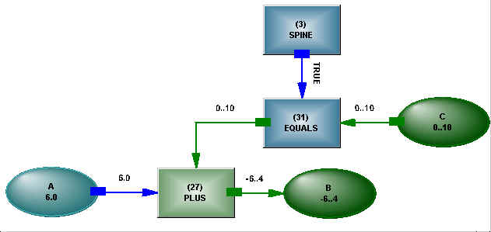
Figure 2: A + B = C as an example of Active Structure
We began with something we call Active Structure². We would like to think it was also inspired by human cognitive activity, but its design goals were more modest than reading text. Active Structure is built in the memory of a computer using nodes and links. Nodes can be variables or operators, and links propagate messages. Semantic activity occurs in the operators, the links propagate the result of that activity, variables distribute that activity and maintain consistency across all their connections. Activity continues until stasis is reached – when no operator is desirous of changing the states in its links. Messages are capable of causing topology operators to modify the structure, and a new connection immediately allows states to flow. The system is capable of hypothesis, changing states, values, directions or connections in the process.
Figure 2 shows the equation
A + B = C
in diagrammatic form. What can be seen is that logic and numbers are tightly integrated, ranges of numbers are tolerated, as are lists and objects. Logical and existential control is exercised through a single connection coming from a spine representing the logical surface on which the statement is written (the blank space around the equation written above has some logical state). The arrows shown in the diagram are dynamic, the structure itself is undirected.
How can it be claimed that inspiration was derived from a neuronal structure?
The detail of the structure, for a start. There is nothing outside the structure, only the states, values and directions in the connections and the semantics of the operators within the structure are relevant. An algorithm moves the states at the behest of the operators, but it is the operators, not the algorithm, which determine the phasing of the activity. There is a logical root (not shown) controlling the spine, and all the rest of the structure builds from that.
Programming is cursed with magic – a magical reaching out to change something, and nothing else can be told about the change or intervene. In a structure, a connection must be established to make a change of state, and other parts of the structure can also make a connection and monitor for change, or dispute it, forcing consistency throughout the network. The directionality of the neural structure is not followed, but breaking this paradigm allows the structure to be used for many purposes, to reason about itself, and to also engage in constraint reasoning, a powerful means of problem solving as the structure becomes more complex. Without directionality, there is no obvious beginning and end of the structure, which we would suggest also occurs as one moves from the periphery to the center of the cognitive core.
We can do a lot with this system, but if we compare
IF A + B = C THEN D + E = F
and
“He thought he needed to exercise the option to extend the lease no later than tomorrow.”
they look like chalk and cheese. The implication looks timeless, while the exercising has a cutoff of tomorrow. We have introduced human intention, which opens up a whole parallel universe. We already had objects, but now we need fine temporal control over relations, and “the lease” – we are talking about it as though it is an object, but it is a relation among the lessor, the lessee and some property.
The “A + B = C” fragment had a clear distinction between variables and operators, but we are going to have to abandon that distinction and make a relation an object so it can inherit complex behavior within context, unlike the PLUS, which is timeless and universal (it has no connection to allow it to be otherwise). And we have different timelines on the two relations – exercising the option will be all over in an instant, but the lease was initiated when it was signed and may last twenty years. The lease can be in a state that causes the option not to exist, so there is considerable cross connection in the statement – it is obviously a much more complex structure than the simple implication, and needs more complex components.

First Steps
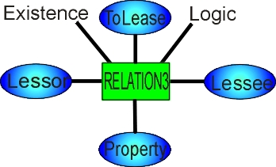
Figure 3: Relation with head, parameters and existential and logical connections
We abandon the rigidity and simplicity of the PLUS operator and create a new form of relation. This relation has a head, which functions as an object, and individual logical and existential connections, so we can handle all the shadings of control, such as
“he is/isn’t/does/has/shall/may/could/would/should/must”
and the time windows that accompany them. The relation still has an operator, which has three roles. It orients the parameters within the network structure, it ensures consistency between the existential and logical states – the logical state cannot be more true, in a Bayesian sense, than the existential state, and it performs the action of the relation.
The way the relation is used will determine whether the logical or existential connection, or both, are connected to the discourse structure –
I can jump puddles.
He ran away.
I thought he ran away.
A further complication is that statements can be made nonexistent by structural reference:
“If liquidated damages are incurred, Section 5.3 is void.”

Adjacency
We might have a vocabulary of fifty thousand words, which has taken thirty years to acquire. We know a great deal about these words, so the structures are nuanced, dense and complex, and necessarily have been built far away from each other We hear words put together in a way we have never heard before and we can somehow bring those nuances together to operate on each other. This is a problem with the notion of direct connection for neurons, but we will leave it for another day. We will create instantiations of the words and the instantiations will inherit what we know, so at least some structure is adjacent. We build the same instantiation, irrespective of how the relation is used – any part of a verb, a noun, an adjective, adverb, a noun participle – its connections change depending on how it is used, but the relation is invariant (we should point out that one of the beauties of natural language is that no rule cannot be broken, so when we say invariant, we mean mostly invariant, and this is not a good application for rules).

Computable inheritance
We already mentioned that neurons know nothing of ontologies or trees or any other forms of passive structure which an algorithm might use to find its way around. We don’t have a million processors lying around, and efficiency is an issue, so we can’t be pure. The inheritance structure is built out of logically controllable operators (the simple active structure we started with) – operators that provide semantics such as invocations (instantiations), members (enforcing disjoint membership), alternatives, meanings (for words with multiple parentage). Specialised operators like PortionOf control the sorts of objects that can be inherited (not indivisible properties) or manage alternatives using constraint reasoning. Other operators can revoke inheritance from objects higher in the structure. Objects are continually moving their connection points into the inheritance structure – something starts out as a gun and later moves to be a Glock 9 mm, while something else increases its generality. The inheritance structure is swept with sets to further the illusion of parallel activity – sets of things an object can be, sets of things it cannot be, sets of things it can have as attributes, and so on.

Object groups
Let’s take the doggerel
Jack and Jill went up the hill
To fetch a pail of water;
Jack fell down and broke his crown
And Jill came tumbling after.
We join Jack and Jill into a new object, we’ll call it an object group. The “and” becomes part of the object group, and controls how the members of the group are accessed. This object group will be the subject of the relation “went”. Now that we have relations as objects, we can form an object group from two relations “fell down” and “broke” (we could treat them as two separate clauses with a common subject, but they may also have a common clause object, so it gets messy, or it gives the wrong meaning – “Jack went up the hill and Jill went up the hill” has a different meaning to Jack and Jill, presumably together, going up the hill). Whether the relational object group shares parameters, or the members have separate parameters can be figured out from the particular relations and parameters (“fell down his crown” doesn’t sound likely). The relational object group may be a causal “and then”, the fall causing the break, again deduced from the relations and parameters. The objects in the object group can acquire properties from the object group (the location of Jack and Jill) or the dynamically created object group can acquire properties from its members.

Relations on Relations
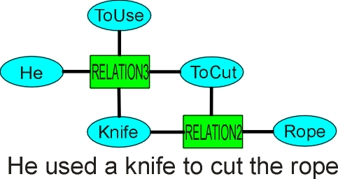
Figure 4: A relation on a relation, where one of the parameters of a relation is a relation
This issue has been fudged around far too long. It can’t be avoided, so how to do it? Making relations objects like any other object is a good start. And objects are often relations – think about what a car is – it is a relation over its components – take the assembly relation away, and you have a pile of spare parts, not a car. Relations on relations can build up regular patterns, as shown in Figure 4. We can chain relations together without end –
“he thought he needed to attend the anger management lectures and seek counseling”
The fine control that writers in particular exercise over this tangle of relations is amazing, until we have to read it four times and almost say the words out loud to get the sense. The system can’t say it out loud, but it can hypothesize about different ways of connecting the relations. More complex jumbles of relations are shown in ³.
Document Structure

“The supplier may elect to exercise the options to be found in Section 5.3(a).”

A scientific, technical or procedural document has a well defined structure, and we can refer to some part of that structure and capture what it contains – not the words but the meaning. We mentioned a logical surface on which a statement was written. That surface could be layered, and there was logical control over those layers, but now we are pointing to a part of the document structure and picking up all of the context it contains – we are moving freely between references to the container and what it contains. This is conceptually no different to “Your order number A123 was delivered today”, where a symbol is used for a complex object, it is just that, for a complex document, it must be a highly organized hierarchical structure, so that Section 5.3(a)(ii) can be identified without error, with that particular small section picking up context from what is above it (sometimes also what is implied below it, but you have to read what is above it to realize that), from definitions of the objects referred to, and references all over the document and in other documents.
We mentioned a highly organized hierarchical structure – is that how people know things? The system can inherit properties for objects, all the way to the base object, and if relations are objects, they can inherit properties too. Well no, it is not as simple as that. Humans inhabit a world that is too dynamic to be captured by a rigid preordained hierarchy. There is a hierarchy in the structure of a large document, with its clauses, subclauses, paragraphs, indexed lists. But there are also actors moving through this hierarchy and present in many places – “Supplier” – and there are many references from one section to another, so a real document like a contract is more like a web – a web of actions and constraints on those actions that the actors must obey – than a hierarchy. Objects don’t inherit properties cleanly – “part of the building is on fire” – which part? We create an ontology to describe the animal kingdom, and out pops a liger, or a viable cross between a horse and a zebra, when the chromosome count is different, or someone clones a sheep, or a female fish turns into a male. The ontology is attempting to describe the limits of DNA, and becomes overrun by exceptions. Rigidity only buys rapid failure. Humans roughly hew to a hierarchy, but it cannot be the sole basis for their reasoning because it breaks down too often. We need to be careful when we assume some biological basis for cognitive operation – a neat tree structure in our heads could be formed out of neurons and sounds plausible, but would lead us to be too dumb to survive. Instead we have a hugely active cognitive structure and are continually “fixing up” the structure (and can be grumpy about doing it, because overturning one shibboleth can bring the whole structure down). By the structure being active, the general and the particular (the patches) can be at the same level in a biological structure – something impossible for a passive and static structure (and a struggle for an active structure with only one active processor, even though it timeshares).
Logical connectives were already handled in an undirected way in the initial system, as just more operators. We are now combining existential and logical states in the one structure. Natural language is about stripping out all the stuff that can be easily inferred by the recipient, so we should expect a mixture of existential and logical states at the logical connectives – “he can’t run (existential) and may have broken (logical) his hip” (and as we have pointed out with Jack and Jill, “and” has a lot more uses than just a logical connective).

Phasing
Phasing of structure extraction is a problem in a large document. If we assume we read the document from start to finish, we encounter, on page 1 in the definitions “Supplier – defined in Section 34”, pointing to somewhere on page 51. It would not be wise to jump there and start reading, because we may find a redirection to page 17, and then page 91. No matter what we try, we will find out some things only after we needed to know what they were. We have to build temporary structure and wait until it is resolved, or complain if it never is. The system is doing a great deal of consistency checking as it proceeds, checking to determine which is the relation or preposition parameter, which is the right inheritance parent. The temporary structure will not be fully consistent, as it lacks full connection.
What does this tell us? It tells us that people are capable of building temporary structure, handling the resulting inconsistencies, and waiting for the structure to be resolved – sometimes all their lives – and that they are capable of handling all the flaws of hierarchies in many dimensions with little complaint, only rarely falling into error. None of these high level properties is obvious from a single neuron, but we can conceive of a general structure patched over time so every change and advance is fitted in at the same level of activity.
We claim to have been inspired by neuronal connections, if not by their directionality. The best sort of inspiration is like a theory, with layers of meaning – the more you look at the inspiring artifact, the more inspiration you find. Grammatical knowledge in the system is held as a huge connected structure, with pattern matching structures ranging from the simplest word all the way to the most complex sentence structures. This structure is searched when a sentence is read, with sets sweeping through it in the manner of an assemblage of firings through a neuronal structure. But then we hit a problem. Something has triggered our searching, but we find an object that is not ready – construction is not completed on some other part of the grammatical structure of the sentence (we could blame this on our single processor, but it would still occur with unlimited processors). How can we restart our searching when it is complete? We could set up looping timers, but they are clumsy and wasteful of computing resources – we want to know immediately something is ready so other processes are not delayed, not wait for a timer to get back to it. We can throw a connection to the object, and when it changes state to indicate its readiness, that change will flow through the connection we have made, reawakening the search. We were allowing operators to control the phasing – now we are adding connections to dynamically constructed operators so they can be restarted. We have used inspiration (but not slavish adherence) to explore what the living system cannot do with the paradigm – making a connection, using it, and destroying it a fraction of a second later.
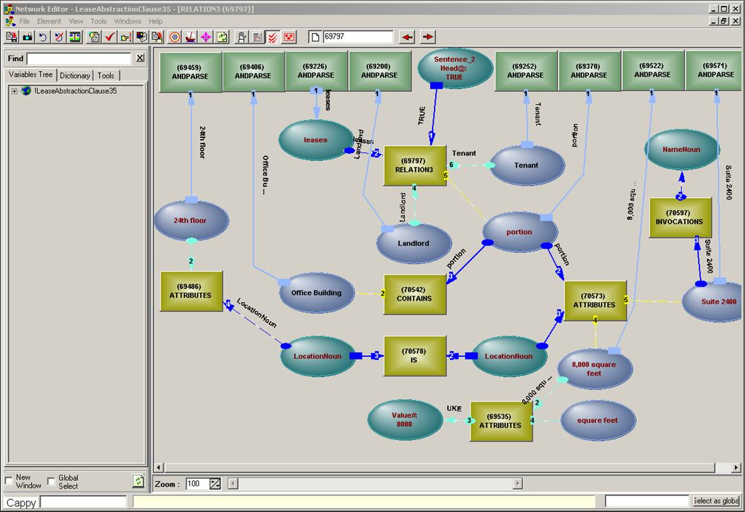
Figure 5: View of structure being generated from text - the structure is seamless with the structure being used to generate it

Active Maps
Prepositions are tricky. They come in a great variety – about a hundred, and some of those with more than twenty different meanings. Some collocate with verbs (worn out), some double as connectives (for), some can turn the whole topology of the structure around (he cut the rope with a knife). What they also do is break the connectionist paradigm. A piece of structure is needed that is detached, and can arrive at a location, assess the connections available, determine whether its particular meaning applies, make the connections, disconnect itself, put itself back on the shelf. It isn’t really detached, it is attached to the object that is the preposition, and they are so heavily used there has to be a reasonably efficient structure for finding the right one, but it is certainly detached from the structure being built, in the way a spanner in a workshop is detached from a car. If you look at real neural nets, what you see is real connections, so how does a biological system with either hardwired connections or a long time delay to make new connections (is it seconds or hours?) arrange for this degree of attachability. We don’t know, what we are doing is building something which has the properties of the system we are reverse engineering. The maps which define the meanings of prepositions are active, in that they will attach to what they find, they use constraint reasoning to determine the validity of the meaning they embody (and give up on any inconsistency), they make or change connections, they will check for the validity of those connections (not everything can be ascertained beforehand – why constraint reasoning is used), they will detach themselves. If they fail, some other map will try. We use the analogy of an octopus. It swims to the site, grasps the connections, ties a knot, swims away to another site, or rests if its work is complete. We can see people demonstrating this ability with all sorts of cognitive problems. It may be in a human that there are enough levels of abstraction to create an area of activation which is essentially able to attach itself to anything (and has about the same range as the octopus, able to manage somewhere between six and nine free connections). We have implemented something much more limited than this, but at least there is a free structure capable of crawling over another structure and changing it.

Diffuse Operators
We may have given the impression that everything, except for Active Maps, is firmly connected together. Not quite. Some operations are diffuse throughout the structure. When we are determining the time attributes of a relation, they may be expressly given, inherited from any level up to the base relation, or implied by equation or inequation from attributes of other relations. Instead of having a huge, frequently updated structure for time management, most of the relations are allowed to get on at their own pace, with detailed timing only being determined on demand. The timing structure that is needed harks back to the simplicity of form of the initial active structure, with the exception that the operator has to search for its inputs, assemble itself, solve for the connections, grab the result, then disconnect itself from everything (a “diffuse” operator). Why do all this – it can very quickly layer, as the creation of one operator cuts the range in one of its inputs, which needs to be verified with the source, forcing the creation of more diffuse operators. The biological neural structure would all go active, we can’t do that so we have to use construction (avoiding the stack, to allow all the structure to be visible and accessible at once) to achieve the same result.
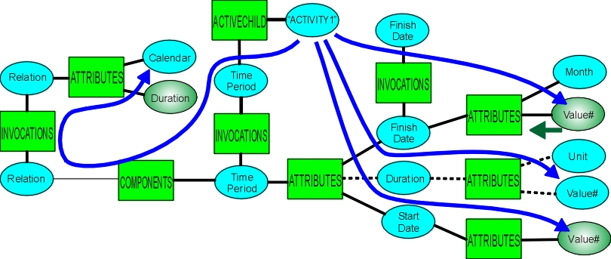
Figure 6: The conditions for construction and evaluation of a diffuse operator, triggered by the arrival of a value for a finish date. The ACTIVECHILD operator provides the semantics.

Applicability
Understanding of dense text may seem a long way from scene analysis or command and control. Hypothesizing about the existence of objects is what detection systems do, so improving the modeling of existence would seem relevant. Conceptualizing relations as objects applies everywhere. Computation of inheritance – it seems unavoidable in any non-trivial knowledge handling application. The fluidity of relations on relations is needed to describe complex human behavior – predicting the behavior of a skillful adversary or of a population under threat. Active maps seem relevant to any situation that requires a combination of global strategy and local adaptation, or where islands of knowledge must be joined into archipelagoes before the relation to the base continent of knowledge can be determined. Diffuse operators are needed to avoid huge and brittle clockwork constructions. They are all needed together to handle a few meaningful lines of text. We should mention the cost – about half a million structural elements for a hundred pages of dense text, and the reading time about the same as for an attentive human. That may seem extravagant, but reading dense text is tedious and boring, and people forget and guess if they don’t know, or are confused by the smearing of different documents together in their heads, some aspects of the biological system that shouldn’t inspire us. An active structure, with its precise detailing of all the connections among complex objects, is bringing context to decision making. That context is required for internal decision making as the structure, driven by text, extends itself, and it can be used for subtle decision making outside of itself.

Structure Building
Extraction of structure from dense text results in dense structure – a structure too dense to build by hand. The obvious approach is to use a machine to build the structure, but it has to be a special type of machine, a machine inspired by the biological system that reads text. The biological system has a neuronal structure before it starts reading, it has a neuronal structure while it reads, and it has a neuronal structure when it has finished. The connections may be denser, but in every other way, its states before, during, and after the reading process, are the same. Fig 7 shows a type of machine that behaves in the same way. It starts off with an active structure, which implements a dictionary, grammatical knowledge, object inheritance, relational prototypes, other domain knowledge. As it reads, it extends its initial structure, so that the new structure can be used to assist in what it further reads. After it has finished reading, it still has an active structure, now augmented by the structure it built from text. The new structure is indistinguishable from the initial structure – it is all made out of the same stuff, stuff which is self-extensible.
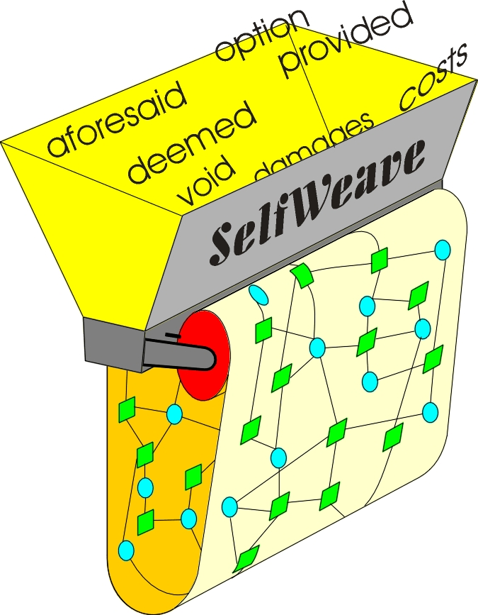
Fig 7 A machine which uses a structure to read text and create structure, which becomes part of the structure to read more of the text, styled after the Jacquard loom, which reads a program to weave structure

Conclusion
Reverse engineering is a useful technique for discovering the components a complex system would need – it avoids the vast gap between a neuron and competent cognitive activity. It still requires we start at a suitable level of sophistication – we couldn’t reverse engineer a jet fighter out of stone (or feathers). We were fortunate in that the system we used as a basis had activity internalized, as a neuronal structure has. We can be inspired by the biological systems we see around us, but direct imitation of their low level components without an understanding of their systems aspects will usually fail to produce their high level behavior. If we blend together what no cell can do and what we see assemblages of cells doing, we can aspire to comparable or superior performance.
We have described the building of a system that can perform a high level cognitive task. Its creation was inspired by the ability of the human to create new cognitive structure and have it immediately operational in building even more cognitive structure, seemingly without limit. Most of the components it uses would seem appropriate for other cognitive tasks of similar complexity. What we saw in reverse engineering the task was the huge amount of cognitive activity required, the massive detail to carry a sufficiently detailed context forward, and the many cleanup tasks at many levels required to ensure consistency of the final result.
Direct imitation of the biological system at the level of a neuron would have blinded us to many important elements of the cognitive system, and would have prevented us from completing the task. Only by submerging the directionality and even the connectivity of a real neural net in higher level organization can a suitable means for carrying out a complex cognitive task be found.

References

¹ “Brain of a white-collar worker”, Lionel Feuillet et al, The Lancet - Vol. 370, Issue 9583, 21 July 2007, Page 262
² “Introduction to Active Structure”, http://www.inteng.com.au/active_structures_cause_earthquakes.htm
3 “Relation structures”, http://www.inteng.com.au/relationstructures.htm

* jim.brander@inteng.com.au; phone +612 9371 0187; www.inteng.com.au

