Copyright 2008 Society of Photo-Optical Instrumentation Engineers.
This paper was published in Proceedings of Defense + Security Conference and is made available as an
electronic reprint with permission of SPIE. One print or electronic copy may be made for personal use only.
Systematic or multiple reproduction, distribution to multiple locations via electronic or other means, duplication of any material in this paper for a fee or for commercial purposes, or modification of the content of the paper are prohibited.

Non-Algorithmic Information Fusion

Jim Brander*
Interactive Engineering, Sydney, Australia

Abstract
This paper considers the applicability of algorithms, constraint solving and active structure across the spectrum of complexity of information fusion applications. Information fusion is recast as a cognitive application using dynamic structure building and constraint reasoning. The similarity between situation awareness and an undirected structure responding to change is highlighted. The efficiency and speed of operation of cognitive information fusion are touched on. A tsunami warning system provides an example which involves multiple threat and demonstrates the difference between segmented algorithms making decisions without context, and the active use of knowledge.

Keywords: non-algorithmic, undirected, constraint reasoning, active structure, self-modifiable, dynamically extensible, cognitive core

INTRODUCTION
Information fusion ranges from combining dense image data streams in a few microseconds, to combining sparse incomplete data arriving over times ranging up to hours. The cost of detection failure or false detection ranges in value from pennies to millions of dollars or life-threatening en masse. In the information fusion systems described in the overview paper by Hall and Llinas¹, there is an impression of directionality up through an inference hierarchy, from sensor to decision. What also comes across in the literature is a mostly passive approach to information fusion. Analogous examples are given where a person will use sight, touch and smell together to identify something. True, but the person while alert is actively using his/her senses to seek out what they expect to find in the environment – they are not just waiting for something to impinge on one sensor and then adding additional sensory information from other senses, they are being proactive and looking for stimuli, which suggests a wholly different approach to sensor input, the sensor input not being the start of an inferential chain but a link in a chain that comes from the cognitive core of the system and returns to it (crudely put, the system knows it has sensors, and actively uses them). For the case of sight and smell, a person sees a rose, then moves their nose towards it, expecting to find a correlation between scent intensity and distance, or, if the sensor is saturated, moves it away – there is a sensory system at work, not passive addition of whatever sensory data is available. If we allow a broader interpretation of situation awareness to include the state before input rather than only after input, we are led to model an active system, not a passive one.
The call for papers for this conference talks about the three A’s, where one of the A’s is Algorithms. This paper will seek to recast information fusion as a cognitive application, where undirected methods such as dynamic structure building and constraint reasoning submerge the directionality of the sensor information in a system.

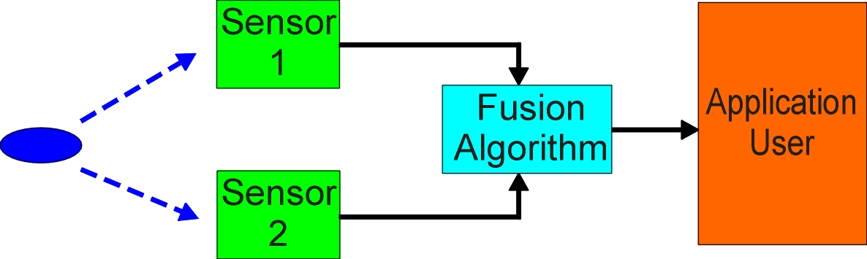
Figure 1. Algorithmic information fusion

Figure 1 shows an algorithmic view of information fusion. The fusion algorithm operates on the data streams from the sensors, but is limited to access to their outputs, and has no recourse to reconfiguration of the sensors. The application user here means either a person or some other non-algorithmic and undirected use of knowledge which takes the fused output. There are obvious areas for improvement – it would help if there was more knowledge about the object being sensed, whether there were likely to be multiple simultaneous objects, whether the sensors are dynamically reconfigurable to improve their signal to noise ratio on selected targets, whether other information in the environment or a sensor history would be useful, and on and on. Let’s assume we have knowledge in many areas, and wish to put it to use. A diagrammatic representation of a non-algorithmic system would look something like that shown in Figure 2, with the sensors brought within the ambit of the system. The connections have changed from being directed to being undirected. Of course there is a strong directionality from the object to be sensed to the sensor, but this is weakened if we are actively looking for the object before we see it, and know what the sensor response should look like. This is certainly the case if one sensor has already detected the object, but other information may also have provided this information – “Expect increased intrusion activity during changing of the guard”.
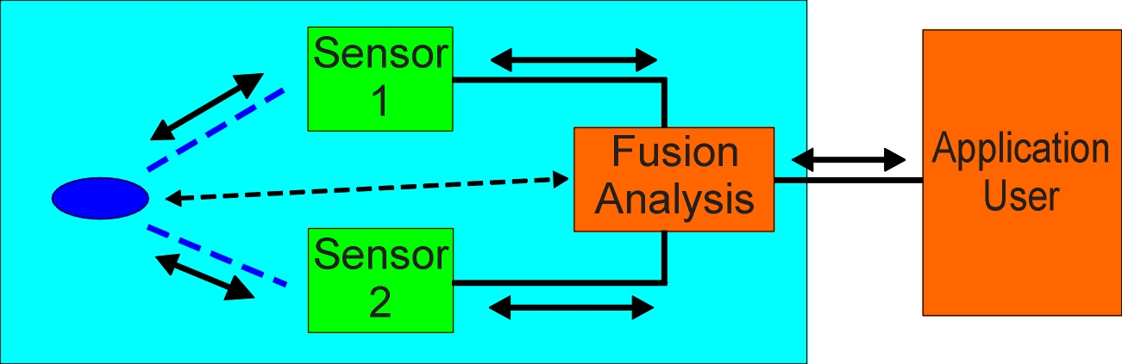
Fig. 2. Fusion using a knowledge-based approach
Many thousands of people have worked on the problem of information fusion, and each of the details we will suggest will have already been included in many clever designs. We are interested in the overall organization of the fusion system – a change from a directed approach to a cognitive approach – rather than any particular detail. The difference will eventually come down to what is possible in an algorithmic framework (we include all directed methods – ANNs), and what is possible in a non-algorithmic framework.

Areas of Applicability
Not all information fusion applications suit a cognitive approach – it is unsuited to very low value applications or those requiring virtually instantaneous response. Figure 3 shows a spectrum of complexity against a spectrum of cost.
If the figure were redrawn to reflect the volume of applications rather than their complexity, it would look very different, with billions of applications in the lower left hand corner, and people filling a largely application-free upper right corner.
In the figure:
A represents biometric matching – high frequency of use, very low to high value, millions of finger prints to check, stable data structure.
B represents tsunami warning – rare, very high value, large delays - an example is given later.
C represents terrorist threat, rare, very high value, often a unique situation, involves human intention and skilled avoidance of detection.
Figure 3 illustrates areas of applicability of three different possible methods for information fusion (assume the axes are somewhat logarithmic). An algorithm without human oversight will usually have an unacceptable failure rate as the cost of failure increases, even for simple applications, due to drift of the problem away from its specification over time.
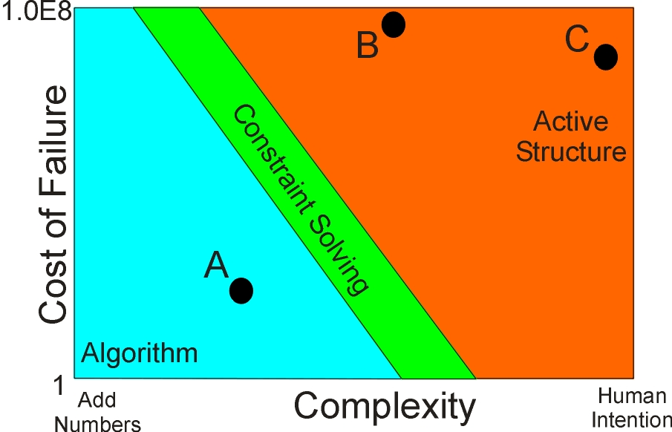
Fig. 3. Complexity versus cost of failure for different methods

Processing Methods

Algorithm
An algorithm implies a data structure on which the algorithm operates. The data structure has no activity, making it passive, and it cannot be changed without changing the algorithm, making it static. The operation of the algorithm external to the data structure and the necessity for their intertwining puts an upper limit on the complexity that can be achieved. An algorithm is by nature opaque – it receives input, performs a calculation, provides an output through an interface. During the calculation, no other part of the processing machine can observe its workings. It will typically use procedures on the stack, so that much of its processing is hidden even from itself. If the calculation is performed quickly and does relatively little, the opacity and delay among its components may be tolerable, but typically the algorithm will grow in processing time and complexity, it being found that segmenting an algorithm into small pieces introduces context difficulties. An algorithm can create, manage and destroy objects, essentially simulating the detection of objects, their continuing presence and their disappearance. An algorithm is typically brought undone by complexities of phasing – I want to do A, but that requires B, which needs C, which needs A – a typical case would be multiple threats, where it is necessary to work out the risk attached to each threat, but to do that the threats of the others needs to be known, as they may be synergistic. If the algorithm is broken into very small pieces, to avoid phasing problems, it loses the context it needs to make a decision. As the algorithm grows in size and is crafted more to its environment, it becomes increasingly brittle – a small change in its environment can cause the need for radical surgery to the topology of the algorithm.
The other specialized directed methods, such as artificial neural networks (ANNs), may have a particular advantage in one aspect of operation, but all can be shown to have similar problems to algorithms in general. An ANN has no method of continuous operation within its paradigm, so an algorithm must be used to give it quasi-continuous operation. It may be thought that, since we are proposing a cognitive approach, and humans use neurons, and an ANN simulates a neural network, that an ANN would be a candidate. Humans may use neurons at a base level, but by layering and back connection, they achieve a cognitive core which can reason about its own reasoning, irrespective of the base element. We will wish to reconcile information in any direction, so will wish to exploit this property of a cognitive system, which must arise many layers above a directed base element.
An algorithm is an excellent choice if there is little that needs to be done – a sensor threshold is crossed, raise the alarm, and that must be done at high speed, the structure of the algorithm remaining stable over a long time. If the knowledge crystallized in the algorithm is tentative or subject to frequent change, or needs to be reasoned about, or the algorithm employs different data structures for different directed methods and these structures need to be strongly integrated, an algorithm becomes very problematic. The combination of an algorithm and a person can reach high levels of complexity, but only at the cost of extensive training and the person doing most of the complex transformations. An algorithm is well suited to those targets or goals which are passive and static or where conversion of the data stream into a more easily comprehended form assists the human.
For example C in figure 3 – we mentioned unique situation. This is not a good application for an algorithm – it is much easier to assemble a knowledge structure out of a number of macro components to represent a specific situation, than it is to have an algorithm sufficiently broad to cover every contingency, including unforeseen ones. This extends to evolutionary algorithms – the exposure to a unique event is unlikely to cause evolution to a solution for that event.
Some extremely sophisticated algorithms have been created in the area of information fusion – in their artfulness and skill, they are reminiscent of the early clockwork chronometers – superb creations, but made irrelevant by a technology that took the time reference down to atomic scale – the digital quartz movement. We will be suggesting that an undirected structure with atomicity of operation can do the same for algorithms.

Constraint Solving
Constraint solving (CS)² as used here means a method of phasing of calculation over a structure based on changes in values at nodes in the structure, where the connections among the nodes in the structure represent relations, and where the structure itself does not change during computation. The relations will not usually be fleshed out in detail, but calculated algorithmically from inputs, so the detail of an inequation like A < B + C * D will be hidden from the solver, reducing the inferences available to it. The benefit of CS is that control passes with change in data. If the set of values for node A change as a result of A being linked to X, and A is linked to B, then new values will be found for B using the relation linking A and B, and so on for the variables linked to B in other relations. Usually, the structure and the memory space for sets at its nodes will have been compiled, meaning the structure is static during computation. The system can hypothesize, by creating a copy of the existing variables on the machine stack. Use of the stack prevents dynamic extensibility of the structure – the system cannot build new “castles in the air”, but only pruned copies of the sets at nodes. Each set of new values at a node must be consistent with the previous set, as the new set is derived from the previous set, stretching all the way back to the initially compiled set. If the system settles, the final set of values on all the nodes is consistent with all of the constraints. A failure to find any consistent value will force backtracking (popping the stack), with other values being tried. Various enhancements are possible, but these tend to be algorithmic hooks, either to describe procedural constraints or provide facilities not easily fitted within the formalism. These hooks damage the integration of the problem and reintroduce the difficulty of phasing a complex algorithm. CS is suitable for solving to a static solution that exists within the problem definition, which means the problem has to be static or known well in advance. CS is not suited to continuous operation, as it has no mechanism for moving directly from an inconsistent state to a new consistent state, and can only retreat on inconsistency.

Active Structure
Active Structure differs from an algorithm in that its structure is undirected and self-modifying, operations are innately atomic, and phasing of its operations, rather than being preordained, is part of what it computes. It differs from CS in that the structure is finely detailed, it is self-modifiable and extensible and the messages in the structure propagate through the structure, rather than being sets of values at nodes. It uses two distinct methods of problem resolution – dynamic structure building and constraint reasoning, usually strongly interwoven (sometimes a formalism can seem to have attractive features, until it is found they don’t combine, destroying their usefulness – the intention of active structure is to have a single underlying formalism of sufficient flexibility that it can do everything).
In active structure, the relations among variables are elaborated until atomicity is reached, with all possible inferences within the structure. Figure 3 shows a simple implication – note the connection of the implication operator to the spine. With this level of detail, there is nothing outside the structure, except an algorithm to propagate the values, the operators themselves controlling the phasing. The result of each operation is immediately broadcast on the appropriate links, so any interested party (some other part of the structure) can connect to it, monitor the result, contribute a new reduction in range, or force a backtrack. There is obvious inefficiency in a structure that carries its context with it, so running a fast feature analysis on a 70 Megapixel scene is not within its range, but an algorithm becomes even more inefficient than such a structure when there are phasing problems or a combinatorial explosion of possibilities arises, or the algorithm has become out of date.
The structure is dynamically modifiable and extensible by the messages flowing through it (the more complex messages, which are structures, are made of the same stuff as the structure through which they propagate). The modifiability of the structure allows for moving directly from an inconsistent state to a consistent state, so it can operate continuously. The closeness of the structural form to the knowledge used in building it means that changes in knowledge are more rapidly handled, and the structure can exploit its undirectedness in the analysis needed for any modification. New knowledge can come prepackaged with hooks to allow it to self-assemble into an existing structure.
The concept of active structure can be used at two levels of complexity – a lower level closer to the output of simple sensors where the operators are those of numerical and logical analysis, and a higher level more suited to high level cognitive reasoning where each relation has individual existential and logical control, this higher level allowing relations on relations (“he indicated a desire to avoid detection”) without limit. The need for relations on relations (representation and activation of complex and layered behavior) appears very quickly in any application involving humans.
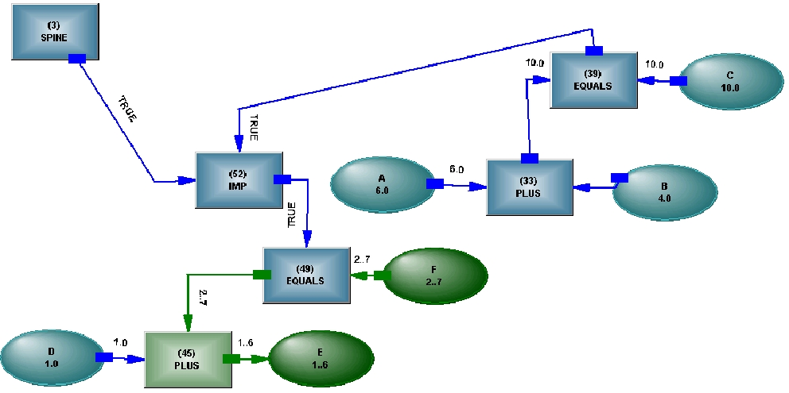
Figure 3: An implication implemented in Active Structure
Active structure has some similarity with a finite state machine (FSM) and shares its tractability – the structure is realized and identifiable, and the states it takes can be understood and directly related to the problem, unlike the jumps of algorithmic code. However, unlike an FSM with its enumerated states, active structure can take an infinite number of states due to its handling of real numbers and bayesian states, and its extensibility. Situation awareness is an appropriate metaphor for active structure – the structure embodies all the relevant values and states to reflect awareness of its environment, and the connections among the objects having those states represent the relations or operations among them. A change in value or state (including creation or destruction of objects or relations) causes either propagation of information until the structure settles and again represents the situation, or modification of the structure if that is the only way to represent the new situation. Existential control can be used to “turn off” parts of the structure that are not present in, or relevant to, the new situation, rather than destroying them (they can be destroyed – it is just more work for the system to recreate them than to simply turn them back on again). This control can also be used to hypothesize about their hypothetical gain or loss.
A simple thought experiment can determine whether active structure is appropriate for an information fusion application – imagine a person standing in place of each sensor. Would they call out simple numbers like “Six” or “Zero” to each other, or they could say – “I think it is six, but there is a bit of noise – what do you see from over there?”, or one person might say – “I can’t see the target because there is a tree in the way” and the other respond – “Look for a person on the right of the tree in 10 seconds”. If the messages among the sensors need to be tentative or confirmatory, to occur in any order or be driven by a cognitive core, and to propagate contextual information, then an algorithm is unlikely to be a good choice.
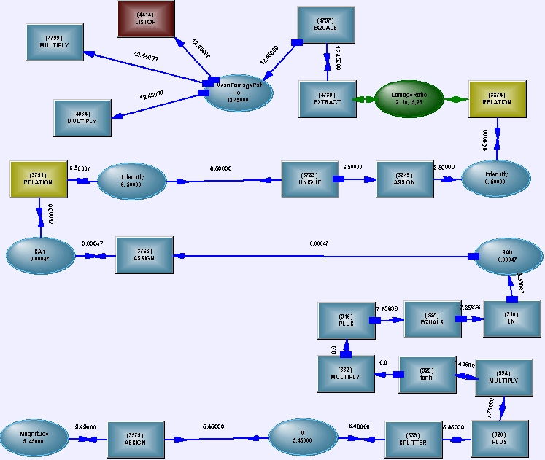
The rationale for active structure is the same as that for the building of any system that must respond to complex situations – complex behavior is most easily achieved by the assembly of relatively simple pieces or pieces that encapsulate well their complex behavior. A physical system like a car can be split into major, relatively independent, components – a chassis, an engine, transmission, wheels. A cognitive system does not allow this simple independence, with much stronger interconnection among its major components, and not one of them being clearly only an input or an output or a directed processor. Also, unlike a physical system, a cognitive system has to hypothesize about the effects of assembling new pieces or removing existing ones – it needs existential as well as logical control over all the objects within its purview, including losing some of its sensors and operating in a degraded state. Existential control isn’t the same as the ability to just create and destroy virtual objects – the system may need to reason about an object or relation which currently appears not to exist – the object is an identifiable part of the structure and its existence needs to be computed.
Magnitude – Event
submodel
Attenuation submodel ⇒ SAh
Experiential submodel ⇒ intensity
Experiential submodel ⇒ Damage Ratio
Figure 4: Various submodels using analytic and stochastic operators
A radical difference between writing an algorithm and assembling knowledge into a structure is that the algorithm writer will want to understand the whole problem before embarking on the development of the algorithm, given the difficulty of reshaping it if it must be changed. New knowledge will always fit with existing knowledge – unless it is wrong, knowledge is both extensible and accreteable – new, more subtle influences can be overlaid on existing structure at any time without damaging the structure, because the structure comes from the knowledge, whereas the algorithm is a directed crystallization of how the perceived knowledge is to be used at a certain time – the knowledge doesn’t even have to change, one may just need to use it in a new way which the algorithm designer did not anticipate.

Dynamic Structure Building
Algorithms can create objects, move those objects about, and reason about them. Where this reasoning breaks down is if there are multiple concurrent threats, or the behavior of the object is too subtle to be captured in a case statement – the object begins to display a combination of behaviors, or the object to be sensed has observed the behavior of our detection algorithm on a previously detected object and seeks to thwart it. As an alternative to static reasoning about objects, we can create objects together with relations and constraints, and use the reasoning in that new structure – we parse the object’s behavior and create behavioral structure that agrees with that parsing – structure whose creation and immediate activation helps us to build more structure. We can then use that behavioral structure to predict what we should see from another sensor, and if we do not find it, come back and change the behavior to agree with what we did find – we have an object free to move and interact with our base structure, and can alter its behavior at will without interfering with the behavior of other objects, unless we presume they share its behavior. This may sound complicated, but it is much less complicated than trying to write an algorithm to do the same thing.

Constraint Reasoning
We have already mentioned Constraint Solving. The difference between CS and Constraint Reasoning in an undirected structure (CRUS) might be compared with the difference between an IF...THEN rule and a logical implication – for the IF...THEN, if the antecedent is true, the consequent is true. For the implication, it can be used forwards, backwards (modus tollens) or sideways (the validity of the implication) – opportunities for reasoning are opened up that are closed to the coarser formalism. Raise this tripling of use to the power of the number of statements, couple in dynamic construction, and the difference becomes enormous – a different paradigm. We don’t have to start out with constraint reasoning in mind – we can start out doing calculations using the structure – conditioning the output of the sensor – if we don’t like the output of our calculation, we change the output to what we would like, and see what we would have to change to get it. A spreadsheet can have a weak form of goal seeking, where an input is varied until an output is achieved, but this would be of little use here. In the CRUS case, the system is propagating numeric ranges, sets of objects, logical states, and it is determining which paths need to change, or what structure needs to be inserted. We don’t have to think about how we may wish to use the structure in the future while we build the structure – all uses are implicit. This may not sound useful when starting out on a simple algorithm, but when it has grown large and complex, and teetering on the verge of collapse, not having to think ahead would have been useful.
A fragment of structure for natural hazard evaluation³ is shown in Figure 4. The structure is combining analytic operators with stochastic operators, while maintaining undirectedness.
Several extensions to conventional constraint reasoning have been implemented:
- For the implication shown in Figure 3, it will not be clear until ranges shrink which part of the structure is providing a logical state to the implication, and which part is providing the numerical constraint.
- Conventional constraint reasoning starts with all possible alternatives, and then prunes them towards a solution. This may be suitable for static problems, but dynamic problems sometimes require more. Just as grenades are only handed out to soldiers on active duty, it may not be prudent to give variables certain alternatives unless one is sure the model won’t blow up as a result. Pattern structures can be used to detect particular situations arising from new structure building, and add particular alternatives in those cases.
- Maintaining consistency across an EQUALS operator normally uses direct ANDing of the ranges or sets of objects on each side. If inheritance is providing some properties in the model, it may be necessary to use hierarchical ANDing. A similar problem occurs with noise – ANDing may require access to many sources, not just two.
- If the process proceeds slowly enough, the user can “hotwire” new constraints as reasoning proceeds, or can back out and change the constraint structure using logical controls. The model to be reasoned about is dynamically created, and can be dynamically altered.
The result of these extensions and structure building during the reasoning process is that the cardinal (and rather simplistic) assumption of constraint reasoning – that the answer lies directly within the posing of the question – can be broken, the question more realistically changing shape as it is worked on, or the solution searched for in a controlled expansion of the problem space using interwoven structure building and constraint reasoning.
The reader may be willing to concede that constraint reasoning could be useful, but wonder how the familiar props of an algorithm, such as a For loop, could be grafted on. There are structural analogs for these things – the fetch store cycle, the for or while loop, with the only difference that logical states are propagated through connections, rather than a jump of the program pointer, so the for loop can sit inside constraint reasoning (and generate an inconsistency to cause backtracking, if absolutely necessary – the backtracking does not rewind the for loop, it only changes back what changed during the hypothesizing).

Overarching Framework
We have introduced the elements of the structure, outlined its capabilities and given some idea of its speed – blindingly fast it isn’t, so it is not suitable for a head up display of the immediate situation, but is suitable for a DSS to be used to extract oneself from a difficult situation.
We will use an example of two sensors, with one sensor detecting an object. The system can infer what the second sensor should detect and reconcile what is detected with what is expected, which may lead it back to the output of the first detector, and attempt to reconcile the output of the second detector, with what would have been expected from the first detector. In the spirit of constraint reasoning, it attempts to close on a solution, moving control around in a non-deterministic manner (this is what is hardest to simulate in an algorithm), making hypotheses, building structure, backtracking out of them, while using any other knowledge available to it. “Attempting to close on a solution” means it shuttles information back and forth down information pathways which can support information flow in either direction, expecting to reduce the problem space as it does so, the phasing driven by the operators responding to the inputs they receive, in a way that would be difficult to orchestrate from outside. The sensor itself is usually quite sure of its directionality, so operators around it compensate for that by taking its output, or providing input to its orientation or calibration controls, so that it appears to respond to what it has been sent. In attempting to reconcile two detections of an object with different sensors, an outcome that lies outside constraint reasoning is that there are two different objects. This is an example where structure building must be intertwined with constraint reasoning. There are other layers needed here as well, layers that control whether the sensor can be allowed to change its sensitivity to home in on a particular target, or it must remain “on station” so that other objects continue to be detected with its normal settings.
Alternatively, external knowledge may lead us to expect to see objects with both sensors, the system develops expectations for each, and performs a different dance in an attempt to reconcile them.
The framework provides a means of managing a cognitive process – a process that does not know where the answer lies, and has no specific sequence of operations to arrive at it. Someone skilful in writing algorithms may find this approach rather unsettling, and may see clearly how to construct an efficient algorithm that will work most of the time. We are assuming a high reliability is required, so the process has to work all of the time, and for this it can be allowed to be inefficient most of the time, just as humans are.
Sometimes the person may become anxious about the progress of the solution, so elements of the tentative solution can be leaked out, under the system’s control, with extrema which it may be using for hypothesizing not shown until there is proof of their relevance. Sometimes the person may be so concerned at the direction the solution is taking that they wish to intervene – the user can hot wire a constraint so the system stops looking at an impossible outcome, the constraint later becoming part of its normal behavior (the ability to hot wire comes from the system not being up its stack – activity is taking place in a grounded structure, with the ability to divert resources at any time to structure building).
We can go further, and provide synthetic input to one or more sensors, based on application knowledge or output of the other sensor. And, depending on the sophistication of the information fusion being attempted, we may be creating complex objects with properties, like intention, that are invisible to sensors, then hypothesizing actions by those objects which will become detectable by our sensors. In this way, we are not just fusing together some information streams to get a more complex product than any one sensor can provide, but using the sensors to align the cognitive system’s internal knowledge with the world, a much higher goal.
Needless to say, hypothesizing in active structure about the objects we may be detecting takes vastly more computing resources than an IF...THEN detecting threshold conditions in an algorithm. The difference in speed is about ten thousand times faster if a single pass algorithm is capable of being used, and infinity the other way if an algorithmic approach fails to capture the complexity. There needs to be a benefit to offset the computational cost, whether extension of the sensor’s sensitivity beyond that available without such means, or reduction of uncertainty in applications having very high cost of false alarm or detection failure.

Example – Tsunami Warning System
A tsunami warning system (TWS) typically uses three types of sensor – seismometers to measure earth tremors, DART buoys to measure deep ocean wave amplitudes, and tide gauges to measure wave height in harbors or on coastlines (other methods, such as GPS, hydrophones or satellite altimetry, are less well developed). There are large propagation delays for signals to reach these sensors (minutes to hours), so threat assessment (TA) needs to be undertaken using partial knowledge from seismometers and then action, which itself has lengthy delays, may be taken, leading to a requirement for situation awareness (SA), an awareness of the current state and urgency of the action, by the system that is combining information from the different sensors. A handful of seismometers near the earthquake and detecting the fastest seismic waves can provide estimates of the magnitude, the location of the epicenter and the depth underground within a few minutes of the event. The mechanism of the earthquake (how the rock has been displaced) and the bearing of the rupture (both of which affect the shape and direction of the tsunami wave radiation pattern) will not be known until more seismometers detect the slower seismic waves, so a worst case scenario (WCS) is erected on the available information (it is not the very worst case, because uplift is not a simple function of magnitude) using an idealized model, and this is used to decide the action to be taken, which may include mass evacuation.
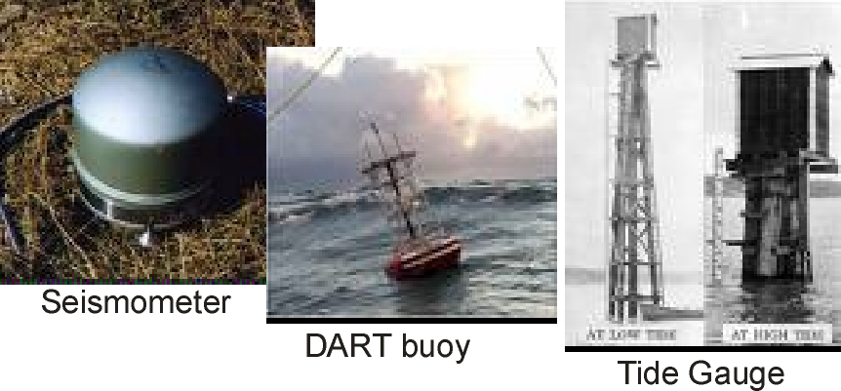
Figure 5: Sensors used in tsunami detection
Modern seismometers are highly sensitive devices with a huge dynamic range, but geographic coverage is often less than ideal, as there may be no convenient island real estate near a fault line under the ocean, and there are other vagaries in seismic wave detection, so magnitudes are averaged, and outliers are weeded out. The early depth and location information, which is based on a handful of signals, may be seriously in error, leading to it being necessary to create an overly onerous WCS, to allow for the possibility of error.
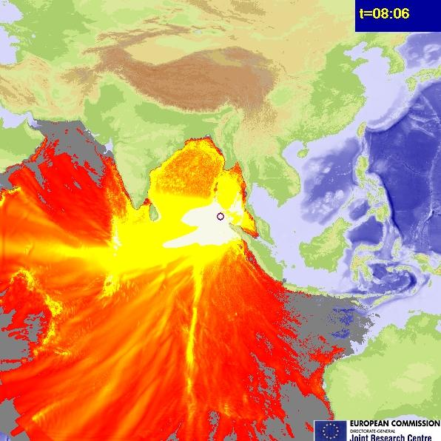
Figure 6: The Boxing Day tsunami, showing a strong directional beam pattern
A tsunami wave from a large thrust earthquake will have a strong beam pattern due to the rapid rupture along a linear fault. Only DART buoys or tide gauges irradiated by this beam will be able to provide confirmation of the amplitude of the wave. A further complication is that the tsunami wave is characterized by a long wavelength, so its apparent energy will differ for small islands (it will diffract around them) or large coastlines, and whether in the lee of an island or in a harbor, and the apparent energy will also differ depending on the rate of rise of the ocean floor and hence the amount of focusing of energy, or reflection of energy from a nearby coastline. A great deal of local knowledge needs to be used to interpret the information from secondary sensors, and yet these are rare events, so learned skills are difficult to maintain in the personnel manning the hazard warning center.

A mature data fusion application across a suite of seismometers scattered all over the globe provides a centroid moment tensor (CMT) solution, giving a more accurate, but much delayed, estimate of the magnitude, rupture mechanism (thrust, strike-slip, etc.), and location of the centroid of the rupture. The information the CMT gives may invalidate the previously modeled wave and cause termination of any action being taken – a strike-slip earthquake will result in a wave many times smaller, and in a different direction – but it cannot more precisely confirm the modeled wave, as a small change in uplift along the rupture, which the CMT could not sense, may result in the beam angle being off a few degrees from a pure broadside, and a few degrees over a thousand kilometers may cause a downbeam sensor to be missed entirely or give a confusing result.
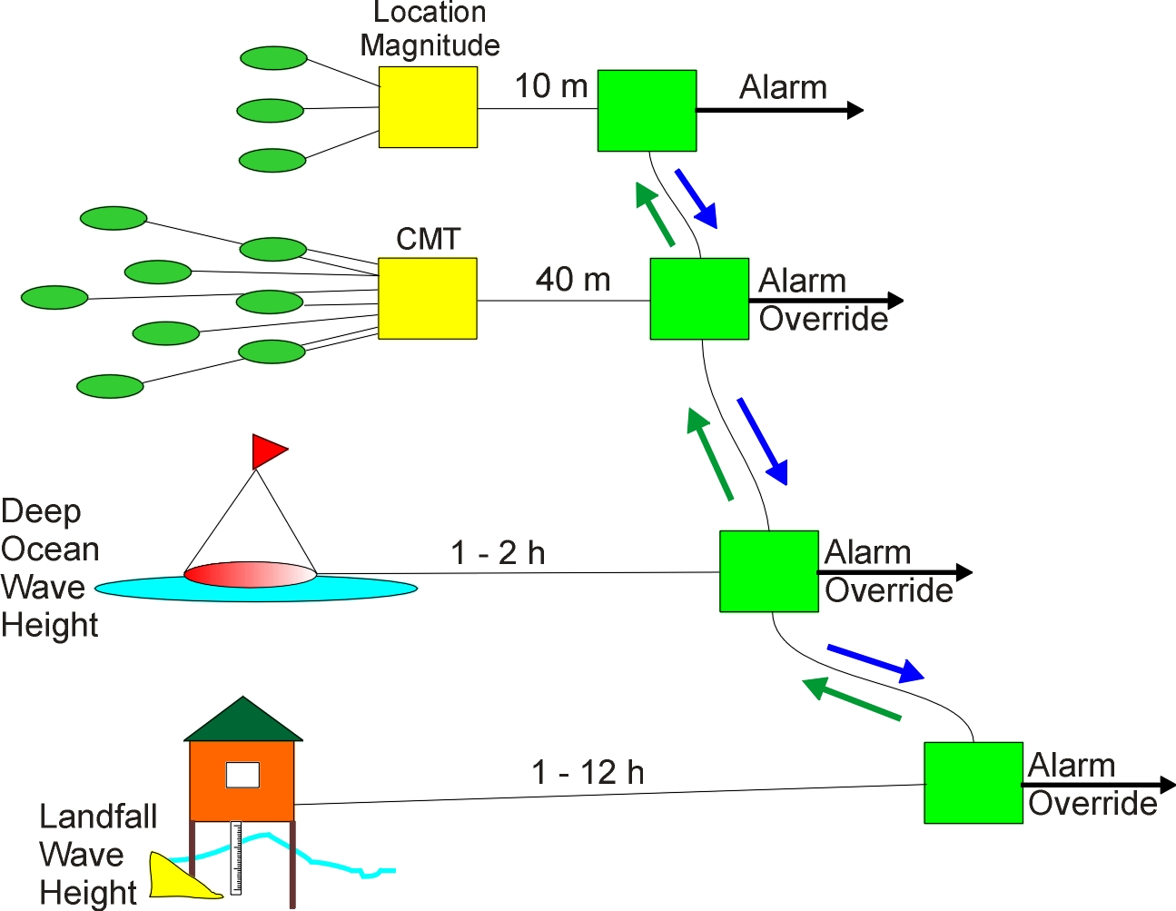
Figure 7: Information fusion for a tsunami, with multiple sensors and varying timelines
Some earmarks of the application –
- Information overload - sensors can provide more information than is currently used – the highly segmented detection algorithms would be overloaded if using all the information
- Speed – there are large propagation delays and the saving of a few minutes to the initial alarm is useful, but threat assessment will continue over hours
- Reliability - a false alarm can result in many millions of dollars of economic loss, a failure to detect a threat can result in thousands of lives lost
- Multiple threat - two close (thousands of kilometers is close) near-simultaneous events can cause confusion or failure of the warning system for both, given that a large earthquake can release a thousand times more energy than the largest nuclear weapon, and the release of energy at one location increases the probability of release of strain energy at another
- Human based system - detailed local knowledge is difficult to maintain in the warning center due to the system’s large geographic coverage, the sensitivity to local conditions and the rarity of the event
- Maturity of science - some of the science is immature and needs to be surrounded by plausibility checking – operationalized science often looks crude, but needs to be much more rigorous than the science of a laboratory

The Mouse That Roared
It is of advantage to the TWS for the detection of a significant earthquake to occur as early as possible, but there may be hundreds of small earthquakes occurring each year – how to quickly tell which one is a significant event? The typical event detection process algorithm is segmented – an algorithm will detect the onset of a P-wavefront in the sensor signal (P-waves are the first to arrive) without benefit of knowledge of other events, another algorithm will wait for perhaps five P-wavefront detections, group them and make a location, and another algorithm will calculate the event magnitude from each sensor, based on an integration of the P-waveform and the location, and average them across the ensemble, discarding outliers. This segmented approach can be easily confused – a P-wavefront from an event on the other side of the world (and travelling through the center of the earth) looks exactly the same to the algorithm as a nearby event, so the location and depth can be way off, to the point where a real event is ignored (this is one of the reasons why one must wait for the system to accumulate enough signals to have some reliability). The combining algorithm is quite capable of creating a chimera – the assembly of signals from different events into an event which exists only in its fevered imagination, but to which the warning system must respond. This is an example where the human must compensate for the deficiencies of the algorithmic approach. There is a great deal more information available, but using it would overwhelm such simple algorithms. Let’s examine the potential information:
Each seismometer has three sensors, typically oriented east-west, north-south and up-down. The vertical sensor will usually have the largest signal, making it the easiest to detect the precise position of the P-wavefront. However, once detected, it is trivial to detect the wavefronts in the other signals from the same seismometer. Using the three signals and the orientation of the sensors, both an azimuth and declination can be calculated. A high declination indicates a signal from half a world away and can be discarded. Is it an elephant or a mouse? – we have a direction and an amplitude, but it could be a small nearby event or a large distant event. We have two ways of estimating the range of magnitude. There is an array of seismometers distributed geographically – if it were a large event far away in a particular direction, it would have been closer to another seismometer, which has detected nothing, so we have a maximum range it could have, which gives us a maximum magnitude of event. Small events have a different noise spectrum to large events – small earthquakes squeak for a short time, large earthquakes roar for a long time, so we can use this phenomenon to put limits on magnitude, and validate the upper limit we already have, or provide an upper limit, if other seismometers are too far away to be useful. With the range on magnitude, we can already tell whether the event is likely to be significant, and begin to steer our use of the array towards it (the array of seismometers is international – we are grateful passive recipients of the signals, but the reliability of any particular signal is poor, and highly structured methods cannot be used – we must use whatever is available at the time of the event). With the direction and a range on distance, we can begin to calculate when we should expect signals at other seismometers - the arrival time, amplitude and duration – we can become active in our response to the unfolding event. There is a philosophy being applied here - use whatever knowledge we have to avail ourselves of more knowledge, which may invalidate our initial knowledge. An algorithm cannot be used to implement such a philosophy – at least not in any thoroughgoing way.
We are suggesting that CRUS is used to manage the shuttling of information around the system, and the reconciliation of the information from different sensors, or different information streams from the same sensors.

Multiple Threats
There may be multiple threats – a large distant quake will make the whole world ring like a bell for hours, so detecting a significant event nearby during that time is difficult. With our knowledge of the distant event, we can create synthetic signals from nearby sensors, and search for significant events within those synthetic signals. To do this requires us to move from simple, passive algorithms, which work well for large, clean signals from the same event and where time can be spent assembling enough signals, to the active use of all of the knowledge available to us. This is something we touched on in the introduction – an animal does not wait for information to arrive at all its sensors and then integrate them, it turns all its sensors on a possible detection – it actively uses its knowledge about itself and the target. Many existing sensor systems already do this – the zooming camera, the steerable sonar array. Where they are weak is where the connections among the signals exist in many logical dimensions (the seismometer and the DART buoy, say) and require the marshaling of more information than an algorithm can easily handle within its limited focus. The active structure approach brings more into focus, as it is responding to influences from many logical and relational dimensions in parallel – the algorithm runs along its fixed code. If we operate at the knowledge level continuously, we can reconcile the new knowledge we receive from other sensors, like DART buoys or tide gauges, with the knowledge we have already assembled about the event, and we can make the knowledge interact synergistically in the way of dynamic structure building and constraint reasoning. If we are restricted to the output of the algorithms in a chain incapable of propagating context, we have waited unnecessarily to allow for the algorithm’s weaknesses, and we have very little basis for further analysis.
The crudity of the algorithmic approach increases the stress on the people who operate the TWS. The factors of information fusion occurring in parallel with threat assessment, high cost of failure, the need for local knowledge and the immaturity of some of the science would suggest a knowledge-based approach rather than an algorithmic approach to the fusion of information from the layers of sensors available to the TWS.
(The TWS has been used to show the difficulty of simple information fusion schemes – it has not been deployed in active structure. Its advantage as an example is that it is not classified and has many of the characteristics of a typical defense system, including unexpected and rapid deployment of massive force, and a multiple threat which can overwhelm defenses with a single point of focus).

Conclusion
Fusion of information is required in a wide range of applications. At some point in the cost/complexity spectrum the fast, narrow and shallow approach characteristic of an algorithm needs to give way to a slow, broad and deep approach based on knowledge. Dynamic structure building and constraint reasoning functionality within Active Structure automates much of the information fusion process at the level of knowledge. Many fusion applications are part of a DSS that is providing threat assessment or situation awareness and where dynamic reconfiguration of the sensors and hypothesizing are required to reduce decision uncertainty. Use of a general methodology which can marshal the information, organize the reasoning process, and integrate the techniques required for information fusion and decision support would seem to be worthwhile for high risk, high value information fusion applications.

References
- D. R. Hall and J. Llinas, “An introduction to multisensor data fusion”, Proc. IEEE, Vol 85, No. 1, pp 6-23, Jan 1997.
- J-Y. Cras, “A Review of Industrial Constraint Solving Tools”, AI Intelligence, Oxford, 1993.
- Acknownet IST Project, http://ec.europa.eu/information_society/activities/egovernment/docs/project_synopsis/syn_acknownet.pdf
- Introduction to Active Structure, http://www.inteng.com.au/active_structures_cause_earthquakes.htm
- Extensions to Active Structure, http://www.inteng.com.au/extension_to_active_structure.htm
- J. Brander, “Multimodal methods of information transmission”, AAAI Spring Symposium, 1998.

* jim.brander@inteng.com.au; phone +612 9371 0187; www.inteng.com.au

