Copyright 2008 Society of Photo-Optical Instrumentation Engineers.
This paper was published in Proceedings of Defense + Security Conference and is made available as an
electronic reprint with permission of SPIE. One print or electronic copy may be made for personal use only.
Systematic or multiple reproduction, distribution to multiple locations via electronic or other means, duplication of any material in this paper for a fee or for commercial purposes, or modification of the content of the paper are prohibited.

Is Mining of Knowledge Possible?

Jim Brander*ª, Alex Lupu**^{b}
ªInteractive Engineering, Sydney, Australia;
^{b}Scio Systems, Chicago, IL USA

Abstract
A method for extracting the complete knowledge structure from technical free text is shown, focusing on particular aspects of the process. Extensions to a basic knowledge formalism necessary to allow building of the complete activatable structure from information-rich text are described. The relevance of the extensions to aspects of information mining is covered, including the resources necessary for mining of knowledge structure in minute detail. The paper gives some examples of the cognitive activity required to automatically read and understand text.
Keywords: self-modifiable structure, undirected structure, active maps, relations on relations, cutting and healing, internalized activity, active structure

INTRODUCTION
Text mining often seems like dragging a hook through the words of the text, hoping to snag something useful. There are extensions – if something is snagged, look nearby for other things that may be useful. The more dense and knowledge-rich the text, the less effective the approach. Most technical text will introduce its own definitions, which can be considerably more complex than just introducing an acronym. For a contract or other document with legal force, there may be a page of definitions near the front, with references to clauses or page numbers where the definition may be found, or the definitions may be sprinkled through the text. Sometimes the definitions are not intuitive (sometimes deliberately so – white may be defined as near black as a trap for the unwary), particularly if the document is introducing new ideas (general meanings can be stretched uncomfortably), and if we do not understand the definitions, we cannot hope to understand the new ideas. Documents also have a layout structure, and will make reference to that structure (see Section 3.(a)), or have a long explanation supporting equation 21 on page 15. A further complication is indexed lists, where a head statement is given, then multiple partial statements, then possibly a tail. Each partial statement needs to be considered with the head attached to its left and the tail to its right, although in the text the actual words may be hundreds of words away (its environment needs to be synthesized). Again, if the method of analyzing the document has no access to the meaning referred to in the structural reference or the indexed list, the knowledge in the document cannot be understood, except in the most superficial way. Methods that rely on statistical analysis are not useful on a single document where precision is required – we may be told something of critical importance just once, and must get it the first time, not hope that it will be repeated so many times it will rise to the hook we are dragging across the surface. If the text is simple and our aim is merely to pluck out a few names and numbers, leaving someone else to read it, existing text mining tools may suffice. Unfortunately, once we have plucked out the seemingly important bits, the motivation to read large slabs of sometimes turgid text is reduced, so people may miss the subtlety of the relations among the objects, or the negation buried two sentences away from where our proximity search ended, or the introduction to a bulleted list, which inverts the meaning of the list item (or worse, the epilog to the list inverts it). Particularly in providing tools for knowledge management, we need to be careful that people do not regress to the tool’s capability. We could decide that complex and knowledge-rich documents are unreachable by existing text mining approaches, or we could choose to develop ways to allow the knowledge in such documents to be more accessible to the people who need to use it. The rest of the paper describes a full frontal assault on the extraction of meaning from large complex documents or collections of documents together, and the armament necessary for that assault.
First, some background. We assume in what follows that the text in a document is a message from one parallel process to another (that is, between people). While text may appear to be linear in form, that is only because it passes through a single-point process – a pen or a keyboard, with one word following another. To describe a complex structure, linear text must circle back, jump to another location, build up islands of knowledge, establish their topography, then link the islands, then describe the geology or flora of an island in more detail, once its relation to the other islands in the archipelago of knowledge is clear. There are many levels of description required in the physical world, with very many more in the logical world, or the world of human intention. The writer - a massively parallel process operating at many levels – assumes the reader is also a massively parallel process, so that information needed to disambiguate the text may be switched among many levels, with the intent that each piece is synergistic with all the others. If the reader is assumed to be competent in the basics of the knowledge in the text, much can be left out, and the grammar can appear to be poor, overwhelmed by the density of exposition. Further, it is obvious that the reader must be an extensible process – what the reader has already read is needed to help the reader to read more – the structure that drives the reader has to be extensible and self-modifiable. The writer takes advantage of this by not repeating what has already been said, or using allusions that are obvious within the context. Given the limits of linear text, if the knowledge front is broad enough, there will be gaping holes in the exposition, and the reader must fence them off and take it on trust that they will be later filled in. We may have given the impression that the writer and reader are of equal power. This is not an accurate picture. The writer may have pored over the document for weeks, the reader must read it in an hour, many hands may have contributed ideas, or the document comes down from Olympus (read: JCS) and is to be read by a humble DSS. If we attempt to break any part of this paradigm and move the text through a static and pipelined or segmented process, we should expect reasonable results on simple text and poor to worthless results on complex text.
It is our aim to catch all the meaning in the text of a technical document – there can be no excuse that our logic does not extend so far, or we don’t know how to fit so many relations together – we said a frontal assault, not an attempt to pick up some scraps of information that are visible to the casual passerby from outside the knowledge structure.
We use examples of text from three areas – genetic abstracts, property leases and supply contracts. They range in size from half a page (a genetic abstract) through fifty pages (a property lease) to a thousand pages (a large defense contract). They range in value of the process described from a hundred thousand dollars (a small supply contract) to ten billion dollars (a large one). They range in quantity from a few huge defense contracts to ten thousand property leases, to thirty thousand genetic abstracts to sixty thousand small supply contracts. They range in the integration that is necessary, from a few property or supply contracts being directly related, to all of the genetic abstracts forming a holistic description. Each of these documents is used as input to a decision support system, if we can characterize a human’s internal use as a DSS. Unless the document is accurately transcribed into the internal formalism of the DSS, the DSS will make mistakes or fall back on other less relevant decision structures. If the text is turgid or complex, or time is too short to read again what has been forgotten, people will guess or smear their memory of documents together. Where there are critical diagnoses to be made, or millions at stake, automation of the process of building the DSS from text may be useful. The problem ranges from fitting very many small pieces of text together, to handling a very large single document.
The difficulties we have outlined for text mining apply equally to document search – without a detailed knowledge of what the document says, including it or excluding it from a working set is problematic. If it will take hours to carefully read, unwarranted inclusion is wasteful. An extracted knowledge structure is much easier to assess for inclusion.

Reading Process

Basis of System
To read technical documents, we need a dictionary to look up words, some grammatical and domain knowledge, an empty shell of a discourse. Bearing in mind the paradigm, that the structure should be extensible and self-modifiable, how those initial components are formed will have a large impact on how successful we can be.
We make the components from something we call Active Structure – nodes and links in computer memory. The structure is characterized by a requirement for massive detail, as nothing outside it contributes to the meaning of the structure. Nodes in the structure can be operators or variables. Operators down at the level of atomic operation examine the states in their links, and change states according to their semantics, so a PLUS operator ensures that the values in all the other links add to the value in its first link, and adjust the state in whichever link is necessary to achieve that, or reports an error. The atomic operation and the immediate broadcasting of the result allows other parts of the structure to immediately respond to any change, including trying to stifle it. Variables serve as identifiable points in the structure and ensure that all their links hold the same value. Information flow in links is undirected, but may be limited by the semantics of the particular operator. Logical states, numbers, numeric ranges, objects, lists, sets and structures can be propagated in the links. The undirectedness of the structure allows every possible use of the structure – it can be used to calculate, or reason about whether it is so. The implication shown in Figure 1 has three uses – as an IF..THEN rule, reversed as modus tollens, and the control connection reversed to determine whether the implication itself is valid. Modeling is achieved by layering of structure without limit – note the logical connections to the EQUALS operators, and how they become connections to the implication, with similar equation structures having different logical uses. An algorithm is responsible for propagating any changes of state in the links, but all state information is held in the structure and the phasing of information flow is controlled by the operators. All changes in state must be propagated through connections (tedious if you are familiar with programming, but necessary). Some operators can alter connections in the structure. We have a structure that is realized, extensible and self-modifiable. The system is capable of hypothesizing about states and values, and about change of structure, making it suitable for a wide range of constraint reasoning problems, as well as direct activity. It was originally created for planning, analysis, scheduling, where the combination of propositional logic and numbers, and existential control at the statement level, will go a long way.
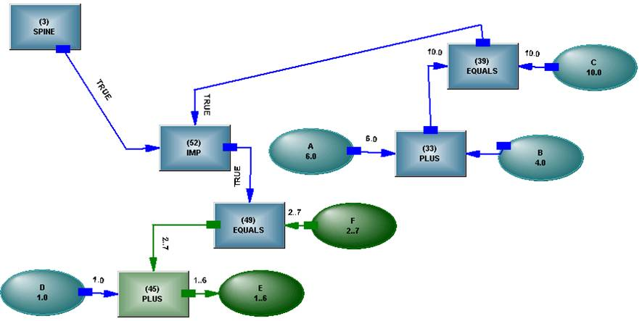
Figure 1: The implication IF A + B = C THEN D + E = F
However,
IF A + B < C THEN D + E > F
looks rather barren and simplistic in comparison with
“He thought he needed to exercise the option to extend the loan”
Statement level existential control is not sufficient where relations among objects are much more complex than PLUS or EQUALS. Every relation may need both existential and logical control from nearby or distant relations, and relations can be layered to any depth within a sentence. The driver for the basic system – controlled numerical analysis – is almost inconsequential for free text, number handling taking up only about 1% of the meaning.

Extensions to Active Structure
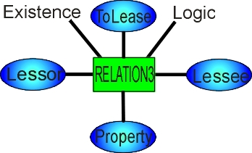
Figure 2: Relation having head, operator, parameters, existential and logical connections
We have added both existential and logical control to every relation¹, as shown in Figure 2. The relation operator maintains consistency between the two Bayesian states – the logical value cannot be truer than the existential value. Both connections will not always be necessary, and one may be stubbed.
The relation has a head variable which functions as an object, allowing the relation to inherit properties and those properties to be controlled, in a way not possible with a PLUS. The relation as object allows us to form relations on relations to any depth, as shown in Figure 3. Unsurprisingly, a great deal of information can be held in these relational patterns.
We need all these things to handle the sentence beginning “He thought...”. The loan may be in a state in which the option does not exist, the option may exist only in a time window (the first three years, say) – all of the objects and relations in the sentence may be densely connected together in an undirected way. We have increased the complexity of the components, but had no choice – the simple components could not be combined to represent the complexity of relations.
Not to be boringly punctilious, we allow the intermixing of existential and logical states at logical connectives, just as free text allows.
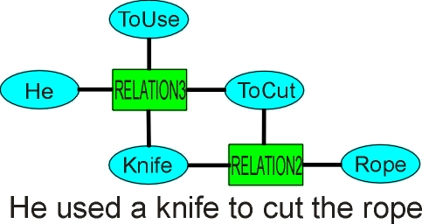
Figure 3: Relation on relation - existential and logical connections not shown
Object groups pop up all over the place. “Jack and Jill” creates a group of objects which become the subject of “went up the hill”. If we created two clauses, we would lose the meaning of them going up the hill together. We can have object groups of relations – “Jack fell down and broke his crown” – the two relations share a common subject and become an object group. We will occasionally encounter lists of words that represent groups, with nested subgroups, and we will need to run consistency over the objects to determine similarity (relying purely on commas is fraught). We are being precise here, but with dense technical text, being imprecise dilutes the meaning (unless precision introduces meaning that was not intended, a danger that needs to be watched).

System Components
Dictionary
The dictionary, as with everything else, is made from active structure. The entries in the dictionary are the objects, so automobile is the object with its properties, and it is also a singular noun. Words with multiple meaning have a meaning operator, so contracts can mean several supply contracts, or the action of a contractor, or something that shrinks, with each meaning also acquiring its object properties. It can be seen that domain knowledge is closely interwoven with grammatical knowledge. The dictionary has entries relevant to the domain – typically about 20,000 words. For any word not found, the system looks up Wordnet² and builds whatever structure it can from the information it finds there (static ontologies intended to be read by an algorithm are not set up for the richness of connection needed for structure building).
The close integration between words and objects can be a nuisance when we are checking for consistency and need to find a common parent. We can disentangle the word hierarchy by requiring that structure which has SentenceWord as its head be excluded, thus eliminating Noun etc. from the parents we find (automobile is an object and has the root object as head, as well as SentenceWord, through Noun).
Local Dictionary
The documents being read that are more than a few pages long will usually introduce defined terms, requiring a local dictionary to be created as the document is read. These defined terms may be collected near the start, or sprinkled throughout the text, or, commonly, both forms are used. Where definitions are collected together, they may have been placed in alphabetical order, so that forward references are frequent – A uses G and Z in its definition, before the definitions for those terms are encountered. We are not talking about simple space allocation for variables in the way a computer language might do it, so there is considerable fixing up required when the definitions are actually encountered. Sometimes there will be a structural reference in the definition – referring to a section or page further in the document. It would be unwise to jump to the area referenced, as we may need definitions of defined terms used there, or the meaning encountered might send the reader somewhere else, forwards or backwards, so it is necessary to build temporary structure and wait for it to be fleshed out. Sometimes the defined term has limited scope – the definition extending only to a section (“for the purposes of Section 3.(a), “Supplier” shall mean...”), and either the general meaning returning outside this scope, or a different meaning coming into force (a problem both for text mining and document search – a further reason to read the document carefully and see what it says). Sometimes the definition of scope occurs after the use of the term, and the built structure needs to be revisited and fixed up. For defined terms introduced within parentheses – “Joe Bloggs (the “Supplier”)”, the term is added to the local dictionary when it is found during the parsing of the sentence, but the sentence will have had the words looked up and instantiated before the definition is added. It is possible for a use of the defined term to immediately follow the definition in the same sentence, requiring the word instantiation connection to be changed during the parsing of the sentence.
The local dictionary requires considerable dynamic behavior as the document is read, with some jobs, such as checking for undefined defined terms or nonexistent structural references, left to be cleaned up after reading has finished.
Grammatical knowledge
Grammatical knowledge is held as permissible pattern structures³ (several thousand) and impermissible pattern structures. The pattern structures are built from active structure, in this case entered textually. A simple permissible pattern:
STRUCTURE1(BodyNounPhrase, {NOCONNECT(StartNounPhrase), StartMiddleNounPhrase, MiddleEndNounPhrase, NOCONNECT(EndNounPhrase)})

Four nodes must match for the pattern to match, but two of the nodes are protected by NOCONNECT operators and are not swallowed up by the resulting structure, which will be built joining its two child nodes into one at a higher level of abstraction (and preventing its child nodes from being seen by other pattern structures). The nodes requiring to be matched, such as StartNounPhrase, are fed by inheritance structures – there can be many symbols that will match each node in the pattern structure (the washing of prunable sets through the structure gives it considerable flexibility, particularly as conjunction of set members can be specified). Some patterns will search left or right until certain conditions are encountered, rather than being strictly bound by direct connection. Some patterns can probe down into the structure already built, searching for a property (including a relational property) that would normally be hidden. Some patterns build a structure whose only purpose is to change or add a property to a node in the built structure, then destroy itself. The notion of adding a property is a departure from conventional constraint reasoning, where typically properties are initialized and only pruned thereafter. In the shifting world of grammar, it is easier to use one pattern to add a property under specific conditions, than it is to use twenty patterns to prevent erroneous matching and building in general.
It would seem that, with several thousand grammatical patterns all desperate to match, maintenance of coherence would be a difficult task. A very simple rule applies. If nothing matches, nothing is built. If one structure matches, that structure is built. If two or more structures match, nothing is built and the developer must increase the discrimination of the patterns. It is possible to assert precedence among patterns, and this is done to ensure a long pattern is built rather than a shorter one of the same type.
Impermissible patterns operate at the level of words, providing a level of pruning before structure building begins. An impermissible pattern:
NOTCONSISTENT(SentenceArticle,Participle)

This form of pattern allows detailed specification of the set members to be pruned once the pattern is recognized (a verbal participle will be pruned, a noun participle will remain).
Collocation structures can be used to clump words, to delete groups of words that have no meaning (fairly common in legal text), or to introduce words into the parse chain that are implicit, such as “the earlier {one} of...”.
COLLOCATION(InsertSymbol,{NOCONNECT(Preposition),INSERTMARKER(PreciseDate, ImpliedRelativePronoun), NOCONNECT(EndNoun)})

It would be possible to have a set of pattern structures to handle word patterns with implied words – it is usually simpler to put the implied word back in the text and let the normal patterns handle it.
Domain knowledge
An inheritance structure is built out of logically controllable operators, such as INVOCATIONS (instantiations), MEMBERS (enforcing disjoint membership), ALTERNATIVES, MEANING, ATTRIBUTES. Inheritance can be controlled by using a NOCHILD operator, so an object low in the hierarchy can be restricted from inheriting properties high in the hierarchy. When a new object is instantiated by reading a word, it becomes an invocation of an existing object through an INVOCATIONS operator, and the structure is seamless from old to new (this approach may seem wasteful, a compiled structure would be much more efficient, but a compiled structure would break the paradigm of dynamic extensibility of structure and introduce a different method of operation).
Relations are conceptualized as objects, and acquire many of their properties through inheritance. Relations also have a prototype structure, linking them to their parameters (and have multiple meanings requiring multiple prototypes – To Give having a dozen).
Prepositions require a mixture of grammar and domain knowledge, and will be discussed later under Active Maps.
Computable Inheritance
The inheritance structure is built from logically controllable operators, so it can be changed according to context. It is not a separate structure, but woven in with every other aspect of the total structure. The inheritance structure is an attempt at efficiency – it could be built from relations, and saves a few thousand links and a little time by not being so, but inheritance must honor relations on objects when it finds them, relations such as ToBe and ToMean (and then needs to check the logical control – the deem relation in “is deemed to be” – how did we imagine we could build a static inheritance structure for a dynamic process like reading text?). Also embedded in the structure are operators, like PortionOf, which control which attributes can be inherited, and handle situations like “Part of the ship is on fire”.
The inheritance structure is heavily used to compute consistency among objects, needed when comparing possible relation or preposition parameters, and this use guides the sort of knowledge we embed in it.

Initial Parsing Structure
The words of a newly read sentence are looked up in the local/global dictionaries, the word objects are instantiated, and a starting parse structure is built. The word and the object are the same thing, or at least an object has its inheritance structure and the word has its inheritance structure, both culminating in the same structure object.
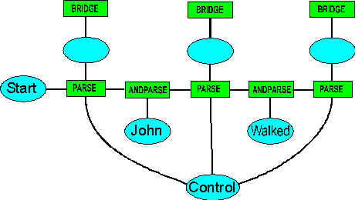
Figure 4: Part of the initial parse chain for a sentence
A fragment of the parsing structure is as shown in Figure 4 (a complicated sentence may have several hundred words, so this is a dense and expensive structure to build, having an enormous number of alternative arrangements to prune).
The ANDPARSE operator arranges consistency between the sets on both sides, so, for example, a participle on one side is consistent with a present participle on the other, whereas if the instantiated word object directly connected to the PARSE operators on either side, it would enforce direct consistency on its links. The ANDPARSE allows hierarchical consistency (another change to conventional consistent reasoning). The PARSE operator takes the sets coming from each side and attempts to reconcile them with the grammatical pattern structures available to it. If the PARSE operator can find no structure that would allow a set member on one side or the other, based on the set members on the other side, it deletes that set member and sends the set back to the ANDPARSE. The ANDPARSE checks across itself for consistency, and may prune the other side or even the same side, then propagates the pruned set. In this way, pruning may propagate in either direction along the parse chain (every opportunity for pruning needs to be taken, given the huge number of alternatives even a short sentence opens up). Collocations requiring direct access to the word level are also handled at this stage, and may clump part of the parse chain, or insert new symbols that are implied by a group of words.

Parsing
When pruning of the parse chain has finished, the Control links are set true and the PARSE operators assemble a set of all the types of objects each of their head nodes can be (notice that the parse head nodes are between the words, not centered on the words themselves) and propagate it to the head node. The head node is a variable, so all it does is ensure that all its links contain the same set, in the process propagating the set to the BRIDGE operator. The BRIDGE operator then begins searching for a pattern structure which will enable its node to be linked to neighboring head nodes. If one is found, the pattern structure is cloned onto the parse structure, the cloned structure broadcasts its head object, which encounters a BRIDGE operator, which begins searching...
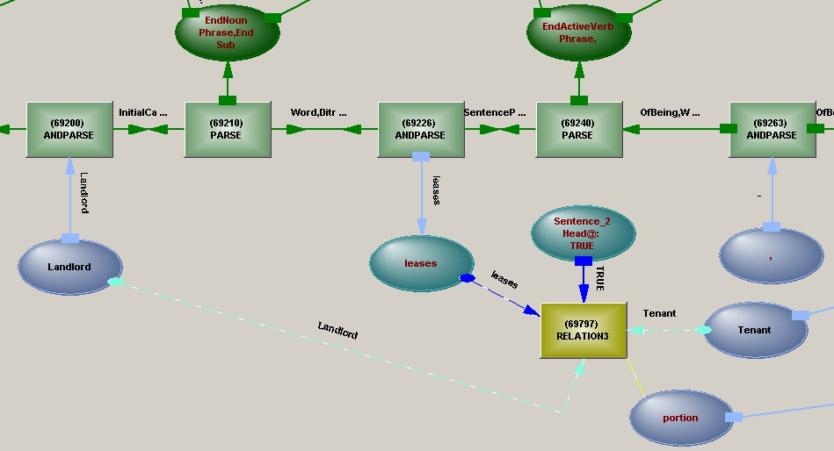
Figure 5: Grammatical structure is built on the parse chain, with relational structure shown built below it - the space is cognitive, so directions are immaterial
There is a great deal of detail glossed over here⁵, but as we rise up through layers of abstraction, we begin to find structures that are not merely grammatical in nature, like BodyNounPhrase, but allow us to build relational structure, like VerbPhrase (a NounPhrase allows us to elaborate the object, which may be a relation, such as “business operations”, and the elaboration may assist us in relational building or parsing – we do anything we can do reliably as soon as we can). In assembling the verb phrase, we may have found a verb auxiliary – “can jump”, or a particular form of verb, such as Ditransitive (“to sell”) or Causative (“to force”) or Clausal (“to think”). We immediately begin building the relation and making appropriate connections where possible, as these connections may be useful in further building of the grammar structure – grammar and semantics are intertwined, because the writer assumes we know both. Figure 5 shows both a small fragment of a parse tree (above the PARSE operator chain) and a small part of the relation structure (below the PARSE chain).
The relation prototype, with its parameters linked into the inheritance structure, is a powerful means of determining what objects should connect to the relation, offering far more detailed information than grammar can provide, and often supplanting grammatical analysis⁴.
The simultaneous building of grammatical and relation structure continues until the entire sentence is recognized and it is fitted into the discourse structure. There are two steps in the process that are identifiable – building the starting structure and fitting the sentence connection into the discourse structure. Between those steps, the process relies on the interaction of pattern structures and the operation of active maps. There is no direction to the process, other than building upward (and sometimes even that does not apply – see next section).

Cutting and healing
Some parts of the parse structure are recognised, built and then cut out – structures such as adverbial phrases, prepositional chains comprising prepositionals, adjectivals and participials, and parenthetical phrases. Cutting out the structure down to the parse chain and healing across the gap means that the grammar can be simpler - it doesn't have to handle the possibility of all these different phrases occurring at every position in the sentence. The removed structure is patched to give it a consistent form and linked via a MODIFY operator to another symbol in the parse structure, with the cut section of the parse chain healed by joining both sides of the cut. This means that, at the level of the PARSE operator, a word acquires a new neighbor and the pruning of alternatives needs to be redone (taking into account any higher level structures that may already be linked to the head node of the PARSE operator). Sometimes the parse chain is cut and rearranged into a more normal form, without removing any structure. Sometimes structure is inserted to represent implied structure. The purpose of this cutting and shutting of the parse chain is to limit the number of pattern structures required.
The modifiers linking the cut structures are respected during the further building of the semantic structure. A long sentence may have a dozen cutting and healing operations on it, together with as many insertions, for implied symbols.

Active Maps
From the rest of the description, and from the illustrations of structure, one can gain the inference that “everything is connected”. Humans have an ability we call the “semantic octopus” – the ability to move to a site of discontinuity, establish context, grasp the loose ends, tie a knot, then move away, with about the same range as an octopus, a maximum of about six to nine loose ends. Such an ability has a weak analog in active maps. Active maps are used to implement the meaning of prepositions, to manipulate structure for collocations, and to connect multiple clauses in a compound sentence – anywhere that islands of knowledge must be joined together in a way that is dependent on what is encountered. A relevant map is given the appropriate parameters – the preposition and the objects either side of it, for instance (maps are clustered on the preposition objects).
Active maps are a valuable resource, and need to be organized to make their access efficient. Searching through every possible meaning of a preposition for a particular relation would be tedious, so direct access is provided for prepositions that are characteristic of the verb, like “warned against”.
An active map first checks that it is appropriate, by attempting to match its structure to the objects it is given. It uses constraint reasoning for this, propagating objects and sets of objects through its structure, where they encounter various operators. A PARENT operator may require a true or false match with a pre-existing set of objects, or may take the resulting logical state and propagate it into a logical network for logical matching. If numeric attributes are involved, units can be used to decrease the number of objects considered (automatic unit conversion occurs). Arithmetic operators within the context of a map operate on the set of objects, so a true EQUALS will prune all objects that do not meet the condition. An alternative approach where calculation is desired is to push a value into a decision network. If no inconsistency occurs, that part of the matching succeeds. A complex simultaneous calculation can be had, by pushing many values into the network in the way of an SQL Select. After matching, the active map begins to alter the structure. Some of the operations the map can perform:
Actualize Actualize implies a match must be found, either in direct structure or inheritable structure. If no match is found, the map fails. If the structure does not directly exist, but is inheritable, it is built. Actualization can extend over multiple levels – a component is actualized, then an attribute of that component, and so on. Actualization is necessary to connect an object with an attribute having a value specific to it, rather than relying on an inheritance path.
Build Structure is built directly from the template given in the map, after detailed checking that it is appropriate. This allows for the creation of new structure that is not directly inheritable, and is most relevant to building new relations among objects or connecting attributes of other objects, such as location.
Replace One object replaces another. Maps need to operate in any order, they cannot wait on each other. A map may wish to build a relation with its clause object, but with no subject it cannot build the structure. It builds a relation with an unknown object as the subject. Another map may then replace the unknown subject with a known object. There is a consistency check, which must succeed if the Replace operation is to proceed (an Unknown object will match with any other object).
Merge Two objects are merged together, the new object acquiring the properties of both predecessor objects. The objects need not be strictly consistent, but must not be inconsistent with each other. Merging is a common operation in a dynamic network structure, as new identity bridges form (one thing is seen to be the same as another - Bill Bloggs is seen as "the man wanted in relation to...", so the objects are merged - a good alibi would have seen the two objects as inconsistent).
Change object An incoming object (one of the parameters) is changed to another object. The usual case is for the incoming parameters to remain as they were in the text, as in "A OF B", the A remains the object of relevance to the rest of the sentence. Sometimes this needs to change - "3% of the cars" will produce a new object "cars" with a count linked by a 0.03 multiplier to the original count – the new object will replace the 3% object in the sentence. This is typical of numeric calculation in general – the objects are linked together by relations, and a separate arithmetic structure using simple form operators is built by the same map to link their numeric attributes and perform the calculations when values become available (when the structure is built, it can’t be known when values will be available – the next moment, or ten years hence. Also, it can’t be known in which direction the calculation will be needed – we have a relation, not an arithmetical assignment).
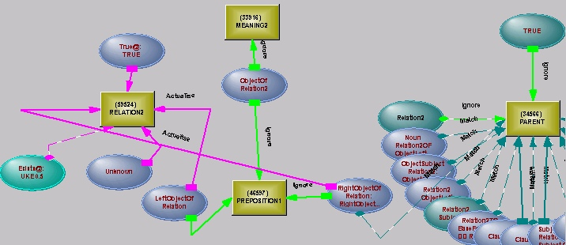
Figure 6: Map for building particular sorts of noun phrases - the right hand parameter is matched as a child of Relation2 (the PARENT operator on the right), then a relation structure (RELATION2 on the left of the diagram) is actualised, with the left hand parameter becoming the object of the relation. An Unknown is built as the subject of the relation.
As soon as the map succeeds in matching and builds the structure, the objects, states and values are pushed into (and out of) the new structure, which may cause switching, cutting of ranges or further building. It may even cause an inconsistency, which will force all the building to be undone and the map to fail.
Some examples
“The house by the lake” – the location of the house will be connected to the location of the lake
“The target was destroyed by small arms fire” – the map provides the subject for the passive verb
“He was forced to fly higher by the storm” – map skips over an infinitive to connect to the subject of a passive causative verb ("He was forced to fly by the lake" would have been handled differently, the lake not being an active agent)
“An option exercisable by written notice” - this is a little more complicated – only a person can exercise an option, so attempting to make "written notice" the subject of the ToExercise relation will fail. The "by" here is short for "by means of", or "using". So the fragment becomes
An unknown person can exercise the option by means of a written notice.
Handling the verb “to use” is one of the trickiest things a preposition does –
He cut the rope with a knife
is transformed into
He used a knife to cut the rope
The map has introduced a new relation, and has cut up and rearranged the structure it found. Of course, the same map would not be used for “He cut the rope with seconds to spare”.
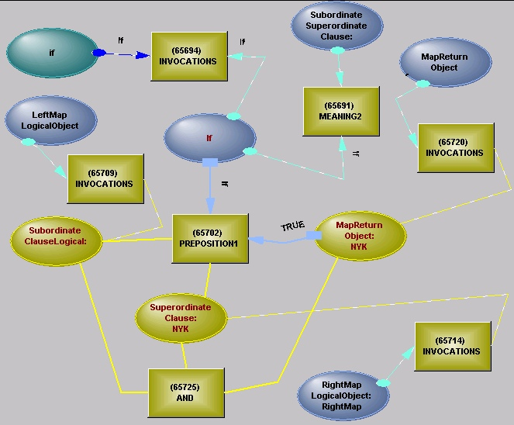
Figure 7: Active map used to join subordinate and superordinate clauses
The prepositional mechanism is also used to handle noun phrases, such as “business operations” (shown in Figure 6) or “helicopter rotor” (object component). A map can include building a script joining the parameters and any newly constructed objects – the script can do things like adding an object to the dictionary or checking a clause reference or calculating a day number (a DateTime). Many prepositions share maps, either directly or by reflection – "the book of John" and “John’s book”, for instance.
Active maps are used as a general way of combining the rich variety of subordinate/superordinate and superordinate/subordinate clauses. Figure 7 shows a map for joining a subordinate If and a superordinate Then clause.(existence connections are handled separately).
Diffuse Operators
Time handling is a problem for a system that wishes to model some area of the world. It can build a huge clockwork mechanism, with timing on every relation, and become bogged down in keeping it all up to date. Or it can allow the components to run at their own pace, only linking together the things that must operate in sequence. This is what people do – we plan where we must, but we get through breakfast without a detailed plan of each step. In building a knowledge structure, the relations with time interactions are modeled. The durations of relations can be inherited, can be directly specified, or can be constrained by other relations or by current time. Time handling is performed by operators which do not exist until they are required, and are then created on demand, allowing them to discover the current time state through the possible paths of inheritance or constraint. We call them diffuse operators, as they spread their tentacles wherever required. They break the direct connection paradigm, because they must discover their connections.

All the Same Stuff
Humans use neurons in their cognitive core – neurons that must support everything – activity, knowledge, the acquisition of new knowledge. Using only one basic component must be inefficient for many aspects of knowledge processing, but it eliminates any problems of interworking. Similarly, the consistent use of active structure across the entire spectrum of grammatical knowledge, domain knowledge and knowledge processing and acquisition eliminates the problems of interworking between different representations and technologies and simplifies the hypothesizing mechanism. The structure is consistent in its form, realized and connectable. Each operator in the structure knows what it should find when it gains control, it can make changes that will survive its loss of control by changing the states in the structure or changing the topology of the structure. There is a single resource that can be used for constructing complex messages in the structure or for adding to the structure. That same resource can be used as scaffolding – the building of a grammatical structure to support the building of the semantic structure, the grammatical structure being reclaimed when the semantic structure is complete. There is an algorithm to connect the active structure to the machine’s activity, but it need know nothing about knowledge or phasing.
The reading process is inefficient in comparison with conventional information processing. While a sentence is being analyzed, both grammatical and relational structures are built. After the sentence has been fitted into the discourse structure, the grammatical structure is reclaimed, but it required effort in its construction and demolition (we should mention that demolition of structure is very like undoing scaffolding, rapid if tedious, and is very unlike the wanderings of memory recovery in a language like Lisp). Even after reclaiming all possible resources, a fifty page document will require about half a million network elements, and take up about twenty times the space on disk of the document itself (the text that generated any particular part of the structure is recoverable from the structure). The text can be read and the structure built in about the same time an attentive human takes to read the document (that is hours at Gigahertz speed for a single processor, against hours at kilohertz speed for millions of processors), but the structure only needs to be read once, and is available for detailed use years into the future. It is also a working model – change a state and everything it affects changes with it. A person reading the text will read it in a particular state – if the state changes, they may remember the direct effects of the change, but be considerably less confident about the spreading consequences of the change without revisiting the document.
The task of building the meaning structure from dense text is not amenable to being performed by hand – the resulting structure, if it is to be precise, is too detailed and dense. While the typical model structure was limited to a few hundred IF...THENs, had no context to support them and represented only a small fraction of the logical interconnections (only the ones thought to be important), it was possible to build logical models by hand. The inclusion of existential logic, time control over both existence and logic, a computable inheritance structure, together with the interconnections of relations and their parameters, makes it essential that the process is automated. Automating the task in all its glory emphasizes the efficiency of free text in describing complex situations, and the limited expressiveness of the existing formal languages or other techniques.

Conclusion
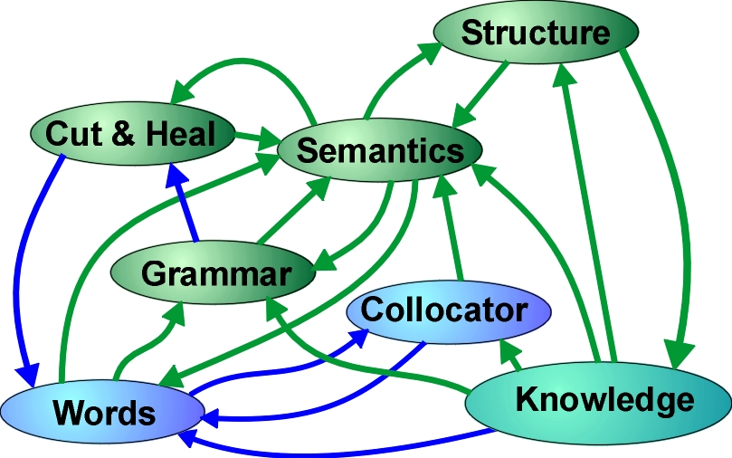
Figure 8: A representation of the undirected interaction of elements of the system
A system has been described that is intended for the extraction of meaning from complex and dense technical text. Development of the system was based on a pre-existing system of active structure, intended for analysis, direct action and constraint reasoning. The elements of the active structure concept have been significantly extended to handle the increased complexity of the objects found in free text, but its foundations of an undirected, realised, self-modifiable and self-phasing structure remain.
If a person wishes to be knowledgeable, to make reliable and insightful decisions without expensive mistakes, they must carefully and attentively read the documents that contain the knowledge they need. If time is pressing or the volume is overwhelming, a machine can be used to read the documents and provide the resulting structure as input to a decision support system. Reading complex technical documents provides a challenge to a sequential single processor machine, so its method of operation needs to be heavily overlaid by a technology that supports a close approximation of parallel activity. The use of an active structure - the combination of atomicity of operation, broadcasting on a network, structure building and constraint reasoning - largely hides the limitations of the underlying sequential processing machine, just as layering largely hides the directionality of the underlying neuron in a human.
To answer the question posed at the start of this paper, the mining metaphor assumes that there are nuggets of gold in the text, surrounded by dross. On the contrary, a well written document has no dross, everything being there for a purpose, and being intended for the cognitive apparatus of a human reader. To automatically extract knowledge from such a document, a system needs to carefully read every word and wring every drop of meaning from it, deploying many of the characteristics of the human apparatus in the process.

References
- Extensions to Active Structure, http://www.inteng.com.au/NLP Operation/extension_to_active_structure.htm
- Wordnet lexical database, http://wordnet.princeton.edu
- Reading legal text, http://www.inteng.com.au/NLP Operation/ReadLegal.htm
- Semantic Octopus, http://www.inteng.com.au/Semantic_Octopus.htm
- Dynamic phasing, http://www.inteng.com.au/dynamic_phasing_in_nlp.htm

* jim.brander@inteng.com.au; phone +612 9371 0187; www.inteng.com.au
** alupu@sciosystems.com; phone 1-847-432-0412; sciosystems.com

