Copyright 2008 Society of Photo-Optical Instrumentation Engineers.
This paper was published in Proceedings of Defense + Security Conference and is made available as an
electronic reprint with permission of SPIE. One print or electronic copy may be made for personal use only.
Systematic or multiple reproduction, distribution to multiple locations via electronic or other means, duplication of any material in this paper for a fee or for commercial purposes, or modification of the content of the paper are prohibited.

Self-Organizing Modeling and Simulation Structures

Jim Brander *
Interactive Engineering, Sydney, Australia

Abstract
The modeling of adversarial intent is compared with another area requiring the modeling of human intent – the representation of knowledge in a contract. The symmetry of the parties to a contract is used as an analog of the symmetry required to model hostile parties, where each attempts to predict the actions of the other. The dynamic construction of undirected, self-extensible structures using associative patterns is described. New methods of constraint reasoning are introduced to allow it to direct the construction of new structure and to allow free structures to crawl over other structures to modify them or to link structures together. The close integration of existence and time with logic and the use of relations on relations in a multi-layered active structure allow the system to be very much closer both to the reality and the intent about which it must infer.

Keywords: Undirected structure, active structure, human intent, dynamic construction, active map, diffuse operator, symmetry

INTRODUCTION
Prediction of adversarial intent under Effects Based Outcomes (EBO) is a difficult problem. We will initially try to show that it is even more difficult than the methods currently used to address it can manage, then show that it is a symmetrical problem – each adversary is attempting to predict what the other will do, while neither adversary can be certain of what they see, because of confusion, camouflage or deception. Current methods of intent inferencing¹ assume that the problem can be decomposed into modular components, that directed structures can be used, and that distancing the inferencing from the problem is acceptable. We will attempt to show that each of these techniques greatly reduces what can be achieved in modeling adversarial intent.

Modular Construction
The advantages put forward for modularization of a framework for handling adversarial intent is that the problem becomes more manageable and that complexity is avoided or reduced. We would argue the opposite – that modularization destroys any complex cognitive problem, or transforms it into a different problem that is easier to solve, but irrelevant to the original problem. With adversarial intent, the goals dictate the actions, and the outcome of the actions reshape the goals – the problem is all of a piece and needs to be handled as such. What is disturbing is that people will modularize a cognitive problem to suit a simple formalism, then regress to the modularization, so that they no longer think about the problem in a general way (or in the way that a general must).The problem is undoubtedly complex, but its very complexity is why it is worth solving synergistically and holistically. We can use structures that compute their own phasing, that have minimum opacity, that are undirected, that have the activity internalized

Directed Structures
Methods that use direction, such as algorithms or rules or artificial neural networks (ANNs) or Bayesian networks, assume that using a knowledge structure in a particular direction is appropriate for a cognitive problem at this level. We will argue that a system should be allowed to phase itself, and should also be allowed to choose the direction in which it uses its knowledge structure. That is, the knowledge structure is initially undirected as to purpose, and can be used for any purpose merely by redirecting the flow of information in it, the redirection occurring at any operator in the same structure. A directed structure needed a conscious choice before the specific problem was seen. It eliminates the possibility of the system being opportunistic and reasoning about its own reasoning. An undirected structure that can direct itself depending on what it finds is exponentially more adaptable than a directed structure.
.

Distanced Inferencing
Both reality and human intent are a tangle of relations on relations, of existential and propositional and temporal logic. If we choose to transform this complexity into a narrow formalism that allows a system to make simple calculations free of any context, we should expect that the system will have little insight into the meaning of the calculation it has performed – we have distanced the system and programmed its inferencing. If, instead, we try to model the situation closely and with fidelity, we should expect a much denser and more complex model, but also a model which is capable of layering its analysis to higher levels that are more useful to its users. We will describe a system which attempts to model what it finds accurately and precisely, without transformation into any simpler formalism.

Symmetry
We wish to predict the intent of an adversary based on their actions or lack of action – we will call the two sides Red and Blue. Some of the Red actions will be based on their perceptions of Blue actions and intent. If we are to model the Red side, we also need to model the Blue side – not just what Blue tells us about their actions and intent, but also the confusion down the Blue chain of command, and how the resulting actions are perceived by the Red side. We end up with several systems – we have the battlefield itself, providing the fog, and two adversarial systems, each of which has a memory, goals and beliefs, observes its environment, formulates plans and takes actions. Goals, in particular, are likely to change as the engagement proceeds. We will assume there is sophistication on both sides, so either side may use deception or delay, or assume the other side is doing so. We will also assume that either side may develop plans that start “in the air” and develop into well-based plans, rather than being plans that are logical extensions of an existing situation. We cannot assume an event-based system, with an action on one side leading to a response on the other. We will require processing to proceed in parallel, with interaction only through degradation of assets, the response to actions, or the lack of response.
Symmetry requires us to model two autonomous systems, constrained by a third, the battlefield. Within that constraint, either of the systems can take any action within their capability, a capability that can be varying drastically with time.

Self-Extension
We will begin a simulation with belief structures for both adversaries. We should expect that each adversary will learn something from the tactics employed by the other. This may include needing to revise their belief structure. It would be of advantage if the initial belief structure could be modified during the simulation – that the initial belief structure appear to be made out of the same stuff as anything learnt during the simulation. If all of the knowledge structures are made of the same stuff, and go down to an atomic level of operation, each adversary will possess the property of self-extension.
We will use an analog, of a system automatically reading contracts. Initially, this may sound a very long way away from the battlefield. We will draw out the similarities, and show the methods required in what seems a much simpler domain. We will attempt to show that the problem is everywhere the same – anywhere that the human cognitive apparatus is involved and operating near its capacity requires certain properties for its modeling and simulation. If those properties are lacking, the modeling will be crude and failure can be shown to be certain in domains requiring accuracy and precision. In domains requiring only a predictive outcome, we may not be able to quantify the error, but should expect performance to be poor.

Analogous SYSTEM
There are other areas where human intent is involved, but few where it is formalized to the point where assessment can be made of the accuracy of modeling. One of those areas is contracts between parties, where the contract formalizes the intent of the parties, often over a long period of time. A contract is written between two cooperating parties and is intended to be unambiguous. The parties trade constraints – “If you do this, I will do this”. Terms are defined in the document – the equivalent of shared beliefs. It may sound easy in comparison with predicting the intent of a hostile adversary, but the writer of the contract assumes the document is to be read by another human and structures it accordingly.
In our working with contracts, it has become obvious how dense the logical and relational structures are if they are modeled with fidelity, with hundreds of thousands of structural elements needed to represent the many layers of interaction. While contracts need to be clear and unambiguous, we do not presume that making decisions on the battlefield is a thousand times simpler than contracting for the supply of goods, so either we are putting too much into representing the relational structures in a contract, or too much is being left out in representing the decision structures in a typical military DSS. We will consider the reasons why it may be the latter – either the sheer tedium of building the necessary structures by hand, or the inability to construct decision structures dynamically. We will show how we can paint new logical structure as need be as we move into new areas, in the manner of a flight simulator scene.

Diversity
Sentences in a contract can run to hundreds of words, providing enormous diversity in what can be expressed, a diversity far greater than one might encounter on a battlefield. Countering that, the contract containing the sentences is nominally unambiguous, whereas the limited diversity on the battlefield is cloaked in camouflage and deception. The contract may be unambiguous when read in its entirety, but much of it cannot be resolved immediately as it is read. The writer is using a single thread to weave a tapestry – here a broad sweep, there a pointillist detail, until finally the tapestry is finished and one can stand back and see the coherent whole. During the process, many things are left hanging and need to be resolved at some later time, so ambiguity needs to be accommodated and carried forward.
The diversity of a sentence is handled by setting up an initial base structure that contains every possible meaning, and then pruning the alternatives at every level as new structure is erected on the base, using adjacency, grammar, relations, collocations, values, constraint reasoning – anything that can be used to convert overwhelming diversity into one or a few meanings, and doing it altogether in any order, opportunistically and synergistically. This is the principal argument against modularization – that it destroys the synergism of knowledge, where any piece may contribute at any time.

Dynamic Construction
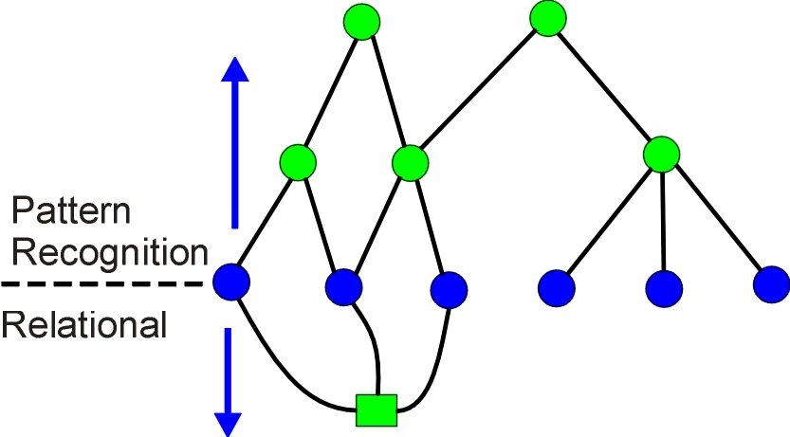
Figure 1: Synergistic structure building - pattern matching builds structure and builds relational structure at the same time, the relational structure potentially providing properties for pattern matching
We can have a pre-existing structure that represents all possibilities, we can assemble a structure to represent what occurs, or we can allow the structure to assemble itself. The first is clearly impossible for sentences, and is only suitable for simple problems within the reach of an algorithm or rules. The second requires that we know how to assemble the pieces to match any situation, now and in the future – we have an omniscient constructor. The third approach has been implemented. Pattern structures – thousands of them – are associatively linked. A node in the base structure representing the current situation becomes active, the system searches for a pattern that can link to that node, finding one, it searches for other nodes that would complete the pattern match. If it finds them, it clones the pattern structure to link the nodes. The head node of that new piece of structure becomes active and the process continues. As the recognition structure is built, the system also builds a relational and logical structure as concomitants of the recognition structure. The relational structure being built may supply properties to the head node, altering the course of pattern matching. Much more happens during the building process – we may use a pattern structure to recognize a pattern and change it to something else, or add a new property to a head node, or cut out some irrelevant pattern. We can use dynamic construction to break the bounds of incremental extension from a base by building relational structure in the air and only linking it to other structure when we can see it clearly – we can recognize something which can act as the seed of a plan. Unconstrained growth in all directions would rapidly lead to exhaustion of resources – we can use constraint reasoning to control the dynamic construction.

Constraint Reasoning
We are interested in probabilistic outcomes, while constraint reasoning deals in absolutes. Still, we should be able to eliminate many impossible plans using it. We need to be careful here – an adversary may very well be following a plan that is impossible, and we should recognize the plan and exploit it, rather than dismissing it. On the other hand, some of the most brilliant battle plans are those that seemed impossible to everyone else at the time (and still seem impossible today). Constraint reasoning can seem very fussy, with its requirement that the solution lie wholly within the well-posed problem space. The fog of war is inimical to well-posed problems. We extend constraint reasoning so it can be used to guide dynamic construction to find solutions well outside the initial problem space. We will need the ability for a free structure to crawl over another, when we are building structures “in the air”. Constraint reasoning can be used to provide guidance for such a free structure.

Analogy Breakdown
Analysing a sentence within a discourse should result in one meaning emerging, or several meanings that need to be carried forward and disambiguated later. The one meaning paradigm is driven by the requirement that only one grammar pattern should match – if more than one pattern matches, none is built and other means, such as outlining, are called on to proceed further (outlining attempts to see “above the fray”, to take a long range view of the parsing structure). The rule that only one pattern should match is not useful for prediction in a battle – several plans may be being executed in parallel, with some plans inconsistent with others, or the plan is evolving.

Table 1: Comparison between reading contracts and adversarial intent
Facet | Reading Contract | Adversarial Intent
Beliefs | Shared | Divergent
Parties | Cooperating | Hostile
Ground | Unambiguous document | Camouflage and Deception
Diversity | 10¹⁰⁰ | 10⁵
Things traded | Constraints | Blows
Level of detail | Extreme | High

Active Structure
We will introduce the basic elements of active structure² and point out some of its characteristics. Then we will introduce the extensions³ necessary to fully represent relations, and use examples to show their relevance to human intent.
Active structure is made up of nodes, operators, links within computer memory, all using a common structural element. All dynamic information exists in the links, or in complex message structures accessible from the links. Nodes can be variables or operators. Variables maintain conformity of state in all their links, operators use changing information in one of their links to change information in any or all of their links, and links maintain information and propagate it throughout the structure. Information flow in the links is notionally undirected, with information flowing in whichever direction is appropriate for the semantics of the operator. Change of state in a link connected to an operator indicates that the operator should be given control to respond to the change, and in this way change of state within the structure controls phasing of further activity within the structure. This relatively simple formalism holds for simple relations like
A + B = C
where the operators are the plus and the equals, and the nodes are the numeric variables, A, B, C and the head of the spine (not explicit in equation). The spine is used to link statements in a model into a discourse (all the statements at this level are ANDed together), and provide them with a logical state (or the spine receive one, as all of the structure is undirected. Figure 2 shows a diagrammatic representation of the structure (the diagram is a direct representation of the machinery, not just a conceptual map for us to understand the operation of an algorithm). In this case the operators maintain consistency on their links according to their simple semantics (a PLUS operator is not necessarily limited to three links, nor is the EQUALS), and the variables maintain consistency among all their links. The structure shows the link between logic and numbers at the EQUALS operator, and the structure is propagating ranges of numbers ( ranges do not rely on pre-existing sets at nodes, à la constraint solving⁴, but are dynamically created message structures) in a direction determined by the logical state of the information (the directions shown by the arrows in the diagram are dynamically determined, the structure itself represents knowledge about a relation among objects and is undirected).
There are several aspects that should be noted, if we are to use this structure as a component of a larger model. The structure needs to be complete in itself, because there is nothing else outside it to give it meaning. People would normally rearrange an equation or inequation to make a different variable an output. There is no rearrangement required here, the directions of information flow change in accordance with the semantics of the operators in responding to input. If we took away the value of C and gave a value to B, it should be clear what would happen. Similarly, if we took away the true state from the spine, and gave a value to B that was not A - C, a false state would propagate out of the EQUALS. Or if we put a false state down into the EQUALS, the equation becomes an inequation. While it has every possible use, the structure itself is invariant. This property makes modeling very simple – a structure can be built without thought as to how it is to be used, then used as a component in a larger structure – a structure which can be decided on later, or even built automatically, and about which the modeler need not know or care how it is to be used. Undirectedness also makes constraint reasoning within the model much more powerful – it is performed at the level of an operator, not a statement, so many more inferences are available – inferences that would be submerged in an assemblage of different operators. Undirectedness allows a set of objects to flow into an operator, the operator change it, and the new set flow out on the same link. There is often communication between centres of activity at some distance from each other in a constraint reasoning model, with information flowing back and forth. It is usually not desirous for tentative information to escape the cognitive core (a single numerical relation does not look much like a cognitive core, but thousands of them, mixed and linked with logic, can perform more impressively), so there are simple means for fencing the area until resolution is complete.
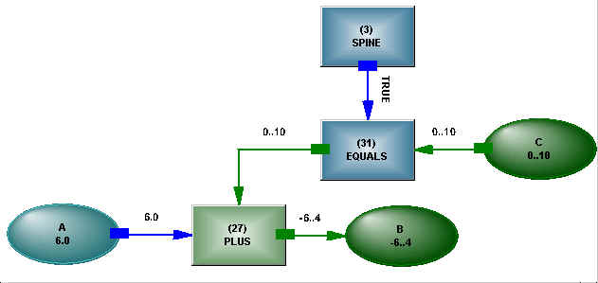
Figure 2: Structure representing A + B = C

The structure is based on connections, with nothing occurring outside of the structure. Connection imposes an iron discipline, but it needs to be weakened under some circumstances, as we will show.
A small static model is all very well, but how to make it suitable for dynamic problems? Some operators are capable of adding or changing connections, so the structure can be self-modifiable. The simple A = SUM(List) statement demonstrates a seemingly trivial dynamism. When the list (another variable) becomes known, an operator, implicit in the statement but explicit in the structure, takes the members of the list and connects them to the PLUS. As soon as a connection occurs, states flow across the connection in whichever direction is relevant. The PLUS operator then operates in the same undirected way as it would in a static structure, either adding the members of the list to give A, or finding the value of a member of the list if A is already known, or pruning ranges, or producing an inconsistency if the numbers do not agree or a range becomes null. A change in the value of the list undoes the construction and kills any values found from the list members. Locating structural dynamism in operators dedicated to the purpose simplifies the operation of the structure. Special purpose operators can represent the behavior of an activity in a project model, or book resources, or store distributions for stochastic information.
Changes in structure elements can be stored, so the structure can hypothesize - it can change values and revert to them, or it can build castles in the air – new variables, operators, links, complex messages, whatever is necessary - and destroy them again (the structure metaphor makes it somewhat like undoing scaffolding). Understanding why an inconsistency has occurred in a constraint reasoning problem, forcing a backtrack, can be difficult. Here, the inconsistency will occur at the level of an operator, with the states viewable around the operator. This small example should make it clear how numeric values and ranges can slosh about in a structure, but it may not be obvious what logical states do, so the next example is of a simple logical structure, as shown in Figure 3: The structure representing IF A + B = C THEN D + E = F.
It may appear that a rather ordinary IF...THEN... has been introduced, but it has slightly more subtlety (and far more detail). Firstly, the antecedent and consequent are of exactly the same form as shown in the previous figure, with just the direction of flow of logical states changed. Secondly, it uses an implication operator, which behaves exactly as logical implication should. That is, modus tollens works. Why bother making it precisely how propositional logic works? This form of logic is an attempt to describe how we reason (it is not complete, but we will come to that), so representing it exactly may have some benefit, in the same way as the system does not need to rearrange equations. The obvious benefit is it is possible to validate, at the strategic level, decision structures that operate at the tactical level. The consequent can be made false, the antecedent will go false, or the true state from the spine can be removed, the consequent made false, the antecedent made true, and the implication will now produce a false on its control pin (there is an obvious analogy with microcircuits, but these operators would make very strange microcircuits, with their undirectedness and their ability to add connections – the latch between a processor and its memory can be conceptualized as undirected, and it certainly changes connections, but in a fixed manner, with no resources to build new connections). In other words, the logical structure models exactly how you might think about the system, even if you don’t bother with the arcane terms of logical reasoning (it is trying to model your cognitive behavior, you should not need to model its cognitive behavior). We have described logic and numbers, and mentioned lists. The structure is self-modifiable, so objects can be created and destroyed (all the referencing structure, such as variable indexing, is made out of the same structure, so the reference is destroyed when the variable is destroyed, or the system backtracks from its construction). What may not be obvious so far is that the basic tools of programming – the fetch and store cycle, or the For or the While loop, or that bane of structural formalisms - a = a + 1, can also be created from operators embedded in the structure – operators which are setting and propagating states, rather than a pointer jumping to instructions in code. We make no apologies for them being less efficient in a structural formalism – an empty For loop is about a thousand times slower - as the ease of modeling with undirected structure and the combinatorial power of constraint reasoning overwhelms the initial speed advantage of programmed code.
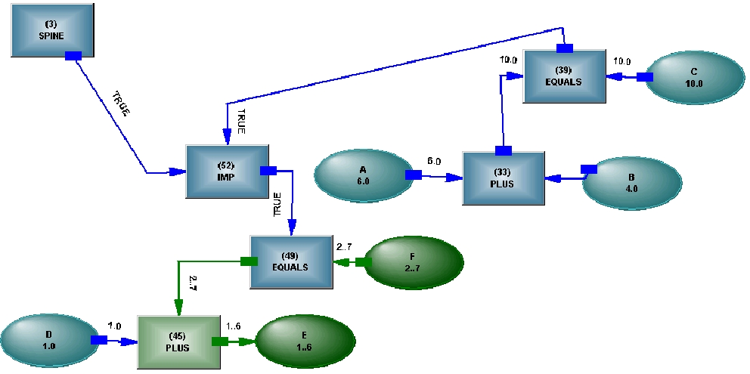
Figure 3: The structure representing IF A + B = C THEN D + E = F
We would say the initially undirected structure represents knowledge, which can be used any way around it is needed, when it is needed. Rules and other directed structures such as ANNs may be useful for getting the message into and out of the cognitive core, but inside that core they are too limited in what they can do – they are a directed traverse of a knowledge structure, which means one had to already know the purpose to choose the direction. Why is that important? – if each connection in the structure only carries half the information of which it should be capable (implication and EQUALS can be used at least three ways around), not many connections are needed before the system is severely impoverished in what it can do. As logical models grow in size, it can become a daunting task to maintain coherence, so having the model contribute to maintaining its own coherence either allows faster construction or more complete models.
The structure we have described so far is suitable for largely static models which can be built by hand, by entering statements which are converted into structure, or by direct editing of the structure. Extensibility and undirectedness means that very large models can be assembled, using contributions of structure, and the contributions can, to a large degree, be self-assembling. If they do not self assemble, they can be stitched together with undirected logical thread, implanting any transformations necessary. However, a largely static model demands a largely static problem, or one changing quite slowly. A defense project may fit that bill, but the battlefield does not. Let’s jump to something a little more dynamic. But first we have to make some changes to the components. Here is a statement:
He thought he needed to exercise the option to extend the term of the loan.
We have gone from a simple statement like A + B = C, comprised of logical and numeric variables and clearly defined, universal operators, to something very different. Now we have relations on relations (“needed to exercise”), we have relations that actually do things rather than just provide logical control or calculate numbers (“exercise the option”), there is existential control - the option may only exist in a time window, or not at all if the loan is in breach, the person doing the thinking may not have the authority to exercise the option. The example is outside of military space, but does show how quickly things can get complicated. We could try to write rules for every which way around this thing could be used, but we would grow tired or bored, and we would still have to tolerate a considerable loss of meaning, because we need to be at the particular relation with all its states to make the right inference, not be pushed away by many little statements attempting to turn simultaneous existential, logical and temporal control on layered relations into a simpler formalism. It is easier to represent all the pieces accurately, then put them together and have the more complex behavior emerge from the assembly. For that, we need to extend the structure we have described so far.

Extensions to Active Structure
We will show that the techniques developed for modeling of the structure of dense technical text are relevant for the area of modeling and simulation of human intent. In modeling of the knowledge structure of dense text, one is interested in accuracy and precision, rather than speed. The massive detail the techniques require may seem prohibitive for an agile system. The detail provides a context, but most of it remains quiescent during dynamic activation of the model, so the model can react swiftly to local changes in state – it can provide a fast reflex arc - and yet is still capable of changing itself as the context changes.
Modeling outside of a person’s head can take two paths – we can use a clever person to crush a complex problem into a simple formalism with as little damage to the knowledge structure as possible (and hope they have predicted any future use, and taken it into account in the crushing), or use a sufficiently complex formalism that the cleverness required is within the capacity of a computer, the modeling process can be done automatically and the knowledge structure is fully preserved, thus allowing for adaptation to ny future use. When confronted with large slabs of text to be handled repeatedly, only the second path seems feasible. We will assume in the descriptions of the techniques that they are intended for largely dynamic models. The changes to the simple form include:

Logical and Existential Control
In the simple form, logical operators, like AND, can manipulate Bayesian logical states, but do not have a separate logical control. An operator like EQUALS, which spans the logical and numerical networks, could be described as having a logical control, but exercising it changes the inferences that can be made in the numerical network, and values in the numerical network can be used to compute the state of the logical connection. The logical connection to EQUALS also carries an existential state – if the state is false, the operator is inactive. The spectrum of “He didn’t run” through “He probably ran” to “He did run” has a different meaning to the logical connection of an EQUALS – it is the probability of occurrence of a relation event (propositional logic takes the true of when an event is occurring, and turns it into a context-free logical state – we need to change it back to a contextful state by linking it to its source relation). We provide all relations with a logical control to describe this probability, and a time attribute to indicate when the logical state is true. We need more. There is a spectrum of possibility too – “He can’t run” through “He possibly can run” to “He can run”. We provide all relations with an existential control to describe this possibility, and they inherit a time attribute to allow the possibility to be under temporal control. The relation operator maintains a logical relation between the logical and the existential state – the logical state cannot be more true than the existential state (the probability of an event cannot exceed its possibility). For many relations, the existential connection can be stubbed true, the logical control going true being adequate to represent reality. In planning models, it is usually necessary to compute existence, and have that affect the probability of occurrence – “it is possible over this range, it is probable over this smaller range”. If the need for existential computation occurs only once in a model, it can be brought into propositional logic and rather clumsily linked to the rest of the model while maintaining undirectedness, but calculate it in a hundred places and it is easier to do so in its own logical world. It would be tedious to require two different types of logical connective to handle the two types of logic – natural language sees no need to handle them differently. The logical connectives in the structure allow the two kinds of logical state to be freely mixed.

Relations as Objects
The simple form active structure had a firm distinction between variables and operators, although there were occasional situations where an operators seemed to need to be a variable too. Mostly, the operators could be simple and universal, like PLUS. For relations, we need to abandon that dichotomy. We have an inheritance structure for objects. It is easy to conceptualize relations as objects, so they can inherit properties too.
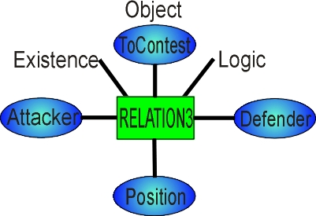
Figure 4: Relation with head node, parameters and existential and logical connections
Many of the things we see as objects are closer to relations than objects. If you think about your car, it seems real enough, but if you took away the assembly relation that holds it together, you would have a pile of spare parts. A contract may look like a piece of paper, but it is also a relation among people with legal force – the piece of paper on which it is written is a physical attribute of the contract, no more. We give the relation a head object, the logical and existential connections mentioned above, we provide orientation of the parameters, and end up with the relation shown in Figure 4.
To make use of this new object, we create relation prototypes, with parameters which also inherit properties. The extra complexity in the object should allow us to model complex situations, but it comes at a cost – we will no longer be able to build large models by hand using simple analytic statements, as we have considerably increased the density of interconnection. Many relations are more complex than this ditransitive one – we have causative (causation relations need careful fitting together, to discriminate among contributory, sufficient, catalytic, and independent causes), clausal (to think opens a parallel universe, and the relation must provide both existential and logical control over that universe), but their complexity is what allows us to model intention. The greater sophistication of the base model elements means the modeler has to think more, sometimes quite hard, to get the meaning right, but the model will do very much more as a result.

Computable Inheritance
There is an inheritance structure, but it is woven into the total structure and is made of the same stuff as all the rest. As new objects are created, they are instantiated off the existing structure, so the structure is continuously extensible from the root. Relations such as To Be, To Mean and To Contain introduced into the structure must be respected in determining inheritance, along with their temporal controls. For efficiency, most of the inheritance structure is built from simple form operators, such as INVOCATIONS and MEMBERS and MEANING (the initial parts of the model may not need multiple meanings, but dynamically created objects probably will). All the simple form operators are under logical control, and can be switched according to context. Special purpose operators such as NOCHILD allow assertion of no inheritance from an object higher in the hierarchy to one lower. In sweeping through the structure, a parent may be found before the connection forbidding inheritance from that parent, so finding parents can be a multi-pass process. Other operators control which properties are inherited for apportionment - cases such as “Part of the ship is on fire”. The inheritance structure is heavily used for consistency checking, and the actual point of inheritance connection for an object may move as more is discovered about an object.

Object Groups
In a model describing the dynamic interaction of objects, groups of objects are forming and splitting all the time. This is another way in which inheritance becomes dynamic. Objects can inherit properties from the group, or vice versa, depending on what joins the group together. Relations can also form into object groups, and relations can have object groups as parameters – “Jack and Jill” is one such group, “running and jumping” is another. Object groups allow a more precise description of the behavior of objects – if we split up the group and describe the behavior of individual members, we lose meaning – we assume that “Jack and Jill went up the hill” together.

Relations on Relations
We use relations on relations all the time in speech and writing. If we build models without this facility, we have to accept that the meaning of the model will be impoverished, and must be compensated for by interpretation of the model’s behavior, with the result that the model loses its most useful property, a means of accurately exploring the dynamics of a situation. With relations as objects, and relations having existential and logical control, we can come much closer to an accurate description of behavior characterized by relations on relations, and we need be much less clever in twisting a simple formalism to capture complex behavior. We all know intuitively how relations fit together in text, so it comes as a bit of a shock to have to actually connect the parameters of layered relations.
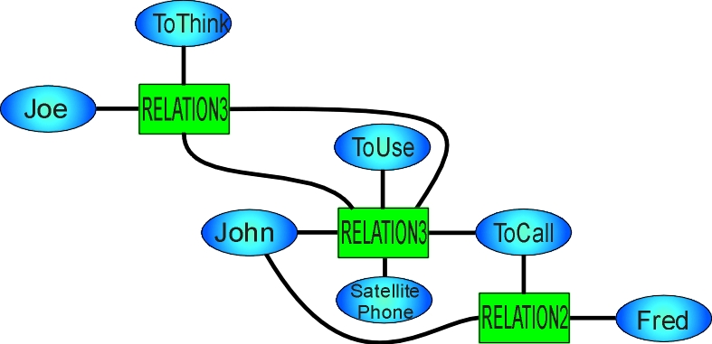
Figure 5: Relation on relation - Joe thought John had used a satellite phone to call Fred – temporal elements not shown

Active Maps
Most of model building can seem like continuous extension from a core, but not always. When there is a base, it is relatively easy to have pattern structures which can recognise a situation and clone their structure to encompass it. Sometimes instead, islands of knowledge are created in a dynamic model, islands that need to be integrated into the rest of the model or linked with other islands, until we can see where the archipelago should fit relevant to the continent of the base model. Building out from a base is easy compared with building structure while pirouetting in the air. The modeler brings a skill here that we liken to an octopus, swimming to the site, orienting itself to the local context, grasping the loose ends and tying them together. If it must be done beyond the reach of the modeler, we need to set up structures that can do this for us automatically (the paradigm of the connected, undirected structure is starting to break down). We use structures that we call active maps for this purpose. An active map arrives on the scene, orients itself by crawling over the structure, determines using dynamic constraint reasoning whether it is relevant to the things needing to be connected, then actualizes (actualization is making manifest the structure that is inherited, so it can be given specific states or values) or builds structure, or merges or changes objects. If an inconsistency occurs at any point, the active map backtracks, undoing any built structure, and withdraws.

Diffuse Operators
A relation may have the start, finish or duration of its existential or logical connections controlled by inheritance, by direct assertion, by constraint from other relations, or by current time. The fine level of detail we are using for temporal control could turn a large model into a hugely intricate clockwork contraption, making it unmanageable. To avoid this, where time elements are not explicit we use diffuse operators – operators which are built on demand, find and gather up their inputs, calculate as necessary, then provide outputs wherever appropriate. Diffuse operators weaken the direct connection paradigm, but could be described as exploiting inherited behavior or implicit connection.

Extensions to Constraint Reasoning
Simple form active structure already used constraint reasoning ⁴ at the level of operators, could prune objects, could use logical combinations of constraints by propagating logical states during the reasoning process (A > 5 OR B < 7), could switch constraints between consequent and antecedent, and allowed backtrack on structure building. However, there was an assumption that the constraint structure existed before constraint reasoning began, not that it would be erected during the process, or it would need to run up, down and across inheritance and relational structures while pruning alternatives. Active maps use a mixture of constraint reasoning, actualization of inherited structure and building of structure, while also merging or replacing objects, providing active structural manipulation, which may occur during the constraint reasoning. Constraints can apply to inheritable properties, so there may no longer be a direct ANDing, and may apply in either direction along the attribute chain – find the object of which this is an attribute, then find another attribute of that object, then match the value of that attribute to this value, handling any necessary change of unit in the meantime. A constraint might apply to the attribute of another parameter of a relation operating on the object, so the map is essentially a free structure and must be capable of crawling across any sort of structure to reach its target. The active map is pruning objects, not values, so the numeric operators in the map accumulate objects which match the values (for the constraint A > 5 in a map, the variable A is a free numeric variable holding a set of value objects). Direct calculation, where that is required, can be had by pushing the value of each value object into a decision network, checking for inconsistency and pruning the set of value objects that way).
Conventional constraint reasoning assumes that all the possible alternatives are initially present (the answer lies within the well-posed question), and pruning proceeds until an acceptable set of objects is left. This is acceptable in static structure, but may not be a wise policy in dynamically constructed structure, the alternatives given out too freely causing mischief in unexpected places. A detachable pattern recognition structure is used to allow the addition of a property to a node when a particular local structure is detected, the property then being pruned or appearing in the solution.
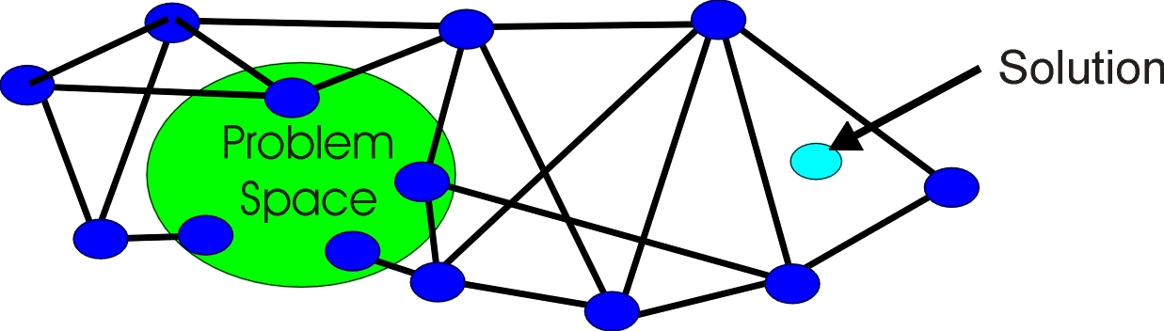
Figure 6: Dynamic construction from Problem Space to Solution
The fussiness of constraint reasoning, the need for the posing of the problem to be so complete that it includes the answer before reasoning begins, has been removed. Hard problems need to be worked on before it can be seen what resources need to be assembled and what compromises need to be made – an adversarial intent model needs equal facility at all stages of the planning process. The combination of dynamic structure building guided by constraint reasoning as shown in Figure 6 allows controlled expansion of the problem space and a much more constructive approach to problem solving.

Structural Tricks
The undirected structural metaphor we are using allows a few tricks. If we run into the situation where the single processor prevents parallel operation of processes, and one process must wait on the other, we can’t rely on the process being retriggered by whatever started it. We can throw a connection to a node in the process on which we must wait, and allow a state to come through that connection to awaken the dormant operator – we can use connections in the structure to allow close interweaving of structure building.
Sooner or later the adversarial intent model will have to deal with multiple threats. We suggest that the place to make decisions about prioritization of threat is not in a stack of procedures, but in grounded structure, where consequences can be hypothesized about, the structures representing the threats can see each other, and a structure can be built on top of them that resolves the decision. Dynamic structure building provides a broader focus in comparison to a static algorithm or rule.

Static versus Dynamic
DSS models using static decision structures to generate stereotyped decisions can be viewed as reliable, but in a hostile situation, the enemy being able to predict your next move is not good. A model built to read text is at the other extreme – it must build new structure to represent what it sees for the first time, and it must be reliable. The techniques developed to handle this situation – pattern structures cloning themselves and expanding from a base towards a goal, the building of scaffolding to support the new structure as it forms, active maps building islands in the sky – these techniques are relevant to models which do not need the extreme capability of reading text, but should still display a dynamic response to the new situations they encounter.

Examples of Use

Defense Materiel Contract
The adversarial intent model is intended to deduce the adversary’s plan from their actions. A typical plan might have been conceived months before, be changed to suit emerging circumstances and put into practice over a few days or weeks. Perhaps we should look more carefully at our own planning processes before embarking on something as difficult as that. A defense contract represents the creation, development and execution of a plan over a much longer time. It demonstrates the weaknesses of the existing planning process, where the plan is segmented because the technology to support an holistic plan does not exist.
If we look at the phases, we have
- Strategic Planning
- Requirements Elicitation
- RFP and bid evaluation
- Project /Program and Contract Management
- Acceptance
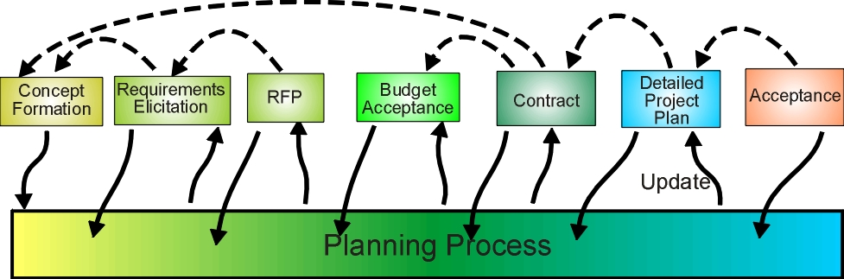
Figure 7: Timeline of complex planning task
The what and the why are laid down in the first two phases, compromise is made on the how and how much in the third phase, and the when is added in the fourth. If only it were that simple. The phases often interact quite strongly, with it being discovered that what was thought possible is not, or at least within the budget, which may vitiate the usefulness of the project product (this sounds very like a battle plan). The basis of the plan should project forward, to illuminate what follows, and reality should project back, to bring reality to wishful thinking. What seems necessary is to develop an holistic plan that connects everything and stays operational over the life of the task, but the strategist talks about projection of air superiority (the why), the designer talks about rate of climb (the what), the budgeteer talks about dollars (how much), the project manager talks about activities and the first batch in three years time (the when), and the manufacturer complains about quality problems with the new composite (the how).
A plan is needed that can stitch all these things together, rather than maintain it in a segmented form. Each submodel is easy enough, it is the effective stitching together that is difficult, unless they use a common formalism.
The similarities with determining an adversary’s plan is that a common formalism is needed from conception to execution, together with the ability to link the execution phase back to the conception phase, so that changes forced on the execution by exigencies can be seen through the lens of the adversary’s intent.

Keeping the Adversarial Intent Model Up to Date
If we slowly build a large and complex adversarial intent model by hand, it is likely to be out of date when it is used, and it can have little local context. If we fall back on a rapidly built, simple model, we can expect problems in its operation, or at least a much heavier involvement by its users in overriding or augmenting the meager analysis it provides. The extensions to active structure we have described were intended to handle the reading of technical text and creation of the knowledge structure described by the text. One option that presents itself is that large parts of the knowledge structure are created directly from strategy documents for both adversaries which are maintained in free text. Maintenance in this form should ensure timeliness of content, and it allows people at all levels to more easily see and comment on the strategies. The knowledge structure, derivable from lengthy documents in no more than a few hours, is augmented with local knowledge and becomes the adversarial intent model. The more transparent form would engender more revisions, but they would be visible textual revisions, transparent to all, rather than the opaque structures or code in use now.
The use of knowledge in such a model sounds like it would be slow to respond in a dynamic battle field situation. If the problem is trivial, then a knowledge structure is either unnecessary or wasteful. As the problem increases in complexity, there comes a point where an algorithmic or any other directed approach fails for lack of subtle phasing control, or blows up from combinatorial explosion, or is forced to do things so crudely to avoid it that the output is worthless – the point where a cognitive application using undirected techniques takes over from an application representing a pre-programmed reflex arc from input to output. A knowledge structure carries a great deal of context with it – most of the context remains quiescent in a situation requiring rapid response – only the parts that are needed are brought into action. A person can use the DSS to simulate a situation and see what it does, but they can also use the context to see why, and they can think about the strategy being used and play with it. The strategy is not a few context-free rules, but layered relations involving many influences, and capable of dynamic construction to handle novel situations – the reason we have emphasized dynamic construction while describing the extensions to active structure.

Conclusion
We have used an analogous application handling human intention to show the benefits that undirected, self-phasing structure capable of self-extension through dynamic construction could provide to an adversarial intent model. The structure is intended to represent knowledge, and be activated internally. While in the main talking about an undirected and connected structure paradigm, we have highlighted where such a paradigm comes under stress, and described approaches within the spirit of the paradigm that may be taken to handle those cases – structures that crawl over other structures to alter them. The level of modeling detail we are suggesting militates against creation of sufficiently densely connected models by a single hand. The undirected structure lends itself to stitching together many contributions, or to automated construction using self-extension.

References
- E. Santos Jr, A Cognitive Architecture for Adversary Intent Inferencing: Structure of Knowledge and Computation, Proceedings of the SPIE 17th Annual International Symposium on Aerospace/Defense Sensing and Controls: AeroSense 2003, Orlando, FL, 2003
- Introduction to Active Structure, http://www.inteng.com.au/active_structures_cause_earthquakes.htm
- Extensions to Active Structure, http://www.inteng.com.au/NLP Operation/extension_to_active_structure.htm
- J-Y. Cras, A Review of Industrial Constraint Solving Tools, AI Intelligence, Oxford, 1993.
- J. Brander, Multi Modal Methods of Information Transmission - AAAI Spring Symposium 1998.

* jim.brander@inteng.com.au; phone +612 9371 0187; www.inteng.com.au

